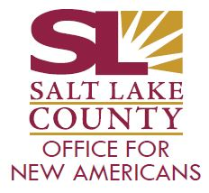
New Americans Civic Academy (NACA)
Session IV
Wednesday, February 22, 2022

WebEx: https://slco.webex.com/slco/j.php?MTID=m6d941cfa069151b5c7cb239cd86731bc

Or
6:00 – 7:00 p.m.

Join by the meeting number
Meeting number (access code): 2499 212 9126
Meeting password: Hubep9vnK43

- Welcome & Introductions: New American Liaison, Joseph Genda 3 minutes

- Arts & Culture – Overview, venues, programs & access, etc. 15 minutes
Presenters: Matthew Castillo, Jenn Niedfeldt, & Craft Lake City Rep, Liz Vowles

- Library – Overview, locations, programs, services, access, etc. 15 minutes
Presenter: Jim Cooper

- Parks & Rec.– Overview, locations, programs, services, access, etc. 15 minutes
Presenter: Liz Sollis

- Q & A 10 minutes

- Closing Remarks 2 minutes

