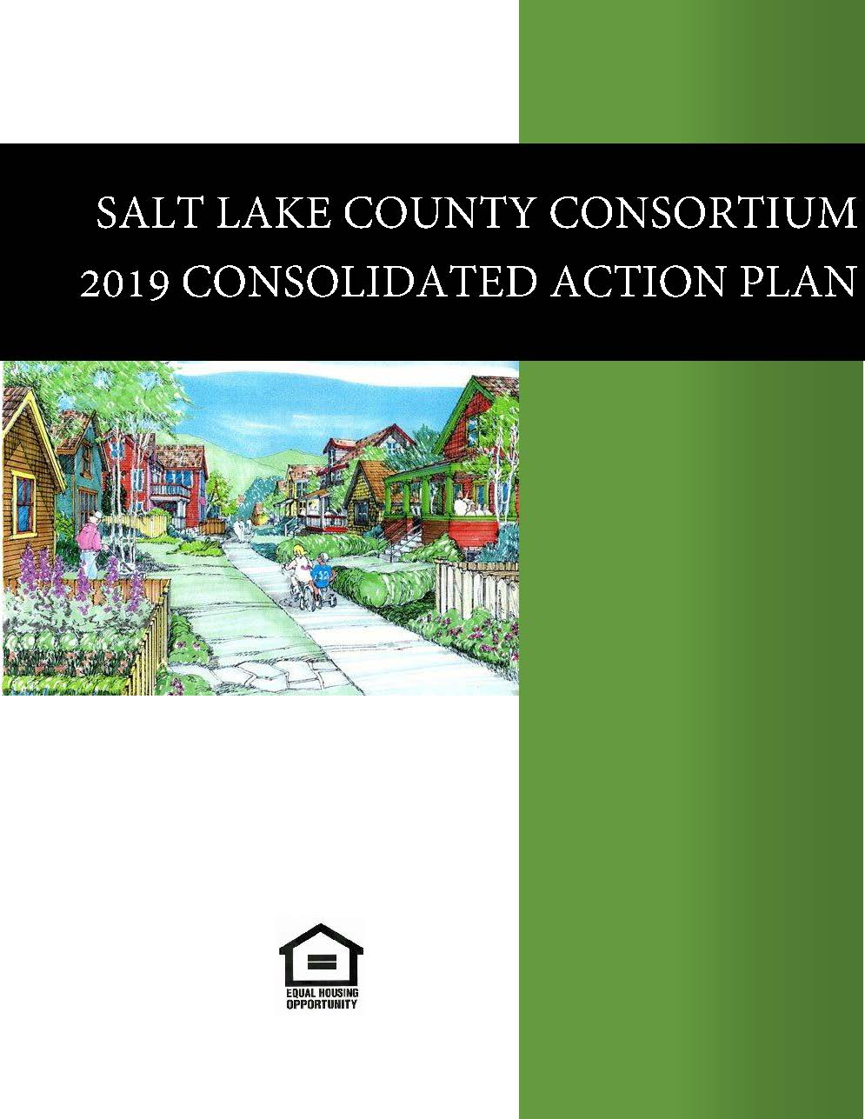

West Valley City amends their action planTaylorsville City amends their action plan to include care act cdbgWest Jordan amends their action plan to include cares act CDBGSandy City hereby amends their action plan to includes cares act CDBG fundingTaylorsville City hereby amends their 2019 action plan.Salt Lake County hereby amends their 2019 action plan to add CARES Act CDBG and ESG funding.Attached to the end of attachment 3 is Amended SF424s,for CDBG and Esg are attached, SF424d, certifications are attached for CDBG and ESGAttached to the end of Attachment 2 is an updated Citizen Participation plan and proof of publication for the CARES act CDBG and ESG fundingSouth Jordan City amended their 2019 action plan to allocate COVID CDBG funds Included is a regular substantial amendment for Salt Lake County reallocation of funds to increase funding for short term rental assistance to help those hurt by the impact of covid 19, we increased the amount for rental assistance by $646,457At the end of the Grantee unique attachments is the legal notice for the request for public comments for this allocation of funds2/15/2021 - Add Round #2 ESG-CV funds in the amount of $2,381,057 & add Round #3 CDBG-CV funds in the amount of $1,303,147. Legal notice for 5-day comment period attached at the end of Grantee Unique Attachments. Citizen comments received after the recommendation of awards for Round #1 CDBG-CV & ESG-CV funds added in the Citizen Participation attachment. **Note - no comments were received after original public notice of proposed use of CARES Act funds; therefore comments submitted were all subsequent to the notification of award recommendations.

Executive Summary

AP-05 Executive Summary - 91.200(c), 91.220(b)
1. Introduction
This document contains the Fifth year action plan of the Five Year Plan for the Salt Lake County Consortium. It describes the allocation of CDBG, HOME and ESG funds for 2019. The U.S. Department of Housing and Urban Development requires any community that receives an allocation of the following grants to complete a Consolidated Plan.
- Community Development Block Grant (CDBG)
- HOME Investment Partnership Grant Funds
- Emergency Solutions Grant (HESG)
This Annual Action Plan reviews the needs of Salt Lake County and details how the Salt Lake County Consortium has allocated CDBG, HOME, and ESG funding to meet some of those needs.
URBAN COUNTY
Salt Lake Urban County includes unincorporated Salt Lake County, the cities of Alta, Bluffdale, Cottonwood Heights, Draper, Herriman, Holladay, Midvale, Millcreek, Murray, Riverton, and South Salt Lake, along with the Metro Townships of Copperton, Kearns, White City, Emigration Canyon, and Magna.
SALT LAKE COUNTY CONSORTIUM
The Salt Lake County Consortium includes the Urban County and the cities of West Jordan, Sandy, South Jordan, Taylorsville and West Valley. Included as part of the Salt Lake County Consortium Consolidated Plan are the Action Plans of Salt Lake County, Sandy City, South Jordan City, City of Taylorsville, West Valley City and West Jordan City.
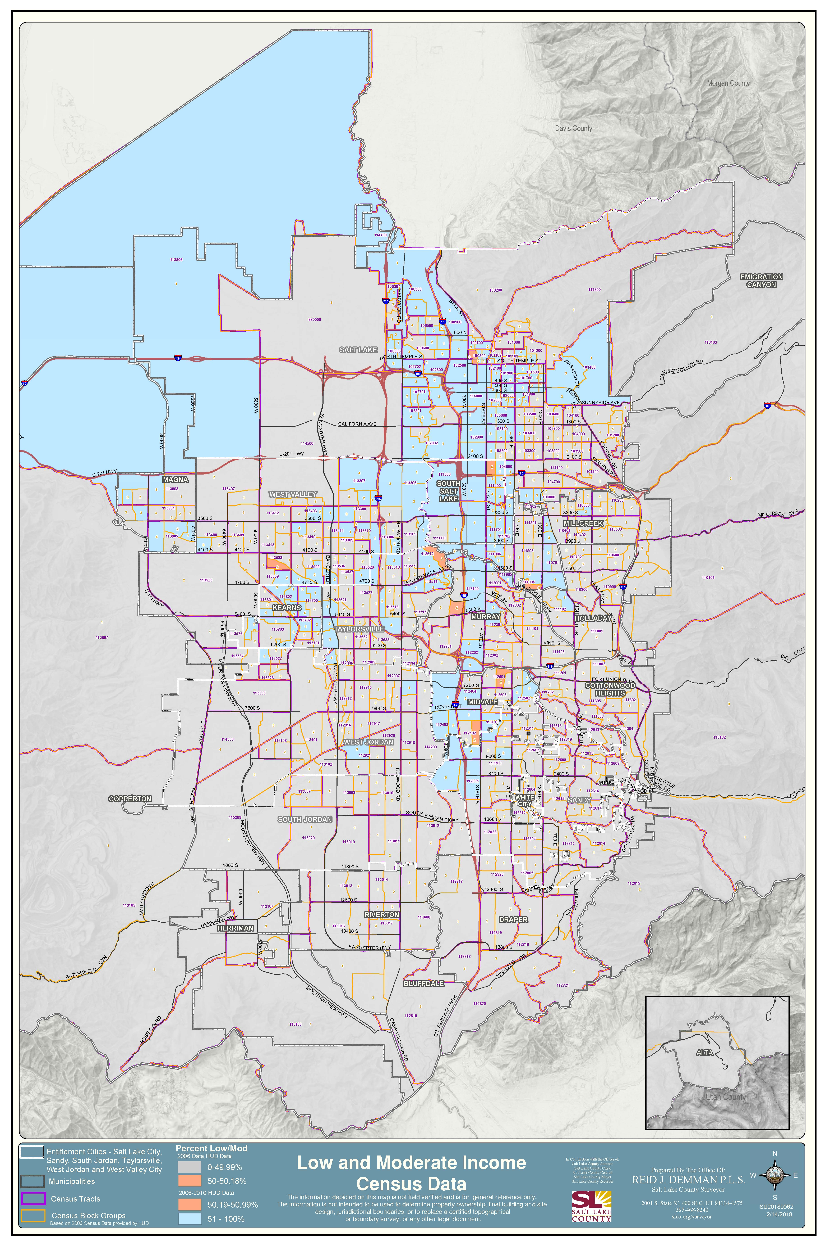
Low to moderate income areas
2. Summarize the objectives and outcomes identified in the Plan
This could be a restatement of items or a table listed elsewhere in the plan or a reference to another location. It may also contain any essential items from the housing and homeless needs assessment, the housing market analysis or the strategic plan.
The objective of the Salt Lake County Consortium Consolidated Plan is to identify the greatest needs in Salt Lake County and through a public process and public input, with input from a variety of agencies and organizations, develop a five year strategy to address and mitigate the greatest needs and in this year's plan layout how the funding received will be used to address and mitigate some of those needs from July 1, 2019 to June 30, 2020.
- Decent Housing-Affordability: Home Improvement Program: 2,000 households over five years or 400 households annually will receive some form of emergency repair, minor home repair, or a home improvement loan/energy efficiency retrofit. Rental Housing: We anticipate building 300 Affordable Rental Housing Units over five years or 60 units annually. Rental Housing for Homeless and Special Needs: 400 units over five years or 80 units annually of rental housing units will be built for the chronic homeless, seniors and those with special needs (In 2017 a Senior Housing project in South Salt Lake City was completed). Tenant Based Rental Assistance: 1,000 homeless households or households at risk of becoming homeless over five years, or 250 households annually will receive short term rental assistance.Suitable Living Environment: Availability and Accessibility; Capacity of Nonprofit Organizations: 175 nonprofit organizations over five years, or 35 annually will receive funding for operations and/or building improvements. Infrastructure, Neighborhood and Park Improvements: 20 projects over five years or 4 annually will be funded and completed. Creating Economic Opportunity and Sustainability; Economic Development: 30 businesses over five years or 6 annually will receive some form of assistance for their business
3. Evaluation of past performance
This is an evaluation of past performance that helped lead the grantee to choose its goals or projects.
CDBG, HOME and ESG funds were committed to a broad range of programs and projects benefiting low to moderate-income households.
Community Development Block Grant Program:
During the last year:
- 247 Home Improvement/Emergency Home Repairs were compelted improving the existing housing stock.
- Accessibility and Fair Housing Education was provided to Agencies & Cities about the importance of accessibility and fair housing.
- Technical assistance was provided to agencies to develop policies & procedures to ensure compliance with program requirements. This is done through on-sight monitoring and desk reviews for agencies identified through our risk assessment process.
- NeighborWorks and was able to provide Down Payment Assistance (DPA) with CDBG funds to 4 low-income homebuyers. Interest in this program has grown & agencies providing DPA are working together to provide better program options for clients.
- 7 Nonprofits received assistance for capacity building and counseling services through Community and Support Services. The County is working to implement more active contract management to better meet program goals and outcomes.
- 8 Agencies received assistance for building improvements for ADA compliance, code compliance or life safety issues.
- 2 Neighborhood/infrastructure improvement projects for 3 projects. 3 were started & two were completed.
- 182 individuals were assisted, 18 new jobs and 7 new businesses were launched for economic development.
- 11 Non-Profit Agencies received funds for community and support services, serving over 11,290 individuals. The individual success was achieved in short-term performance indicators that marked progress towards long term outcomes.
Emergency Solutions Grant Program: With the new regulations in place, in the last year, 3 Agencies were provided funding through the ESG program. All Agencies matched funds at 100%.
- Rapid Re-housing: 128 homeless families were stabilized in permanent housing with a short-term subsidy and supportive services, accomplished through financial assistance for rent and deposit payments and stabilization services through case management. 87% of families that had a positive exit to unsubsidized housing did not return to shelter for a minimum of two years.
- Diversion from Homelessness: 653 families presenting at the shelter in crisis received an assessment and were successfully diverted from entering the shelter
- Emergency Shelter: 765 women and children who were victims of domestic violence were sheltered and experienced reduced abuse. 203 women received case management services while sheltered, resulting in increased income for at least 33 women. 71 women had new or maintained employment and 43 were stabilized in permanent housing.
HOME Investment Partnership Program: Over the last year the following was accomplished:
There are five rental housing projects which are under construction and will be completed by the end of 2019 or the first part of 2020
Community Development Corp. of Utah (CDCU) through the provision of down payment assistance helped 20 households buy a home
CDCU completed the purchase and rehabilitation of two Idea Houses
GHHI projects completed: Through a HOME funded 41 projects were completed
Tenant Based Rental Assistance, rapid rehousing, short term assistance was provided to a 250 households
The required monitoring of all existing HOME rental housing developments was completed
Accessibility and Fair Housing: Education is being provided to landlords.
4. Summary of Citizen Participation Process and consultation process
Summary from citizen participation section of plan.
A notice of the 2019 Draft Action Plan, 2017-2018 CAPER, and the Citizen Committee funding recommendations was made available for public comment on March 30, 2019. Comments could be made up until May 3, 2019. A public hearing on the proposed allocation of funds was held April 17, 2019. All comments received at the hearing & any written comments were reviewed before the final allocations were approved by the Mayor on May 6. 2019. No written comments were received. Outreach for the Public Notice was provided through newspaper ad, press release, email to the County Diversity Website list & their newsletter, email to all interested parties on County's list, notification through Utah Housing Coalition newsletter, & information on County webpage.
The 2015 five year plan development started on October 2013. A needs assessment was completed to gain a better understanding of the community needs of low to moderate-income households in Salt Lake County, Utah. The purpose of the project was to help inform the allocation of limited resources, namely Community Development Block Grant (CDBG), Social Services Block Grant (SSBG), Emergency Solutions Grant (ESG) and (HOME) Home Investment Partnership Program funding, to organizations whose programs can best address the needs of low to moderate-income households in the County. Starting in October 2016 a new Needs Assessment was started to further define the areas of focus. The needs assessment was completed in a multi-step process including 1. Literature review of prior needs assessments; 2. Coordination and guidance from the HCD Director & Program Managers; 3. Public Comment Process; 4. Internal stakeholder meetings and 5. HCD follow up with internal stakeholders.
In particular, the Public Comment Process (Item #3 above) greatly informed the finalized identification of needs. The Public Comment period was administered through two in-person meetings held on September 23, 2013 and the September 25, 2013 as well as an option to submit written comments through September 27, 2013. Prior to the public comment period a draft copy of the needs assessment was posted on the Housing and Community Development web site, a legal notice was run in the Salt Lake Tribune & Deseret News on September 8, 2013, & email reminders were sent to community organizations. Public response was representative of a range of community organizations and individuals. In total, 27 organizations & 2 private citizens engaged in the public comment process.
The first part of January, 2017 HCD hired a consultant to do a survey to help identify the greatest needs in Salt Lake County. Attached is the full report.
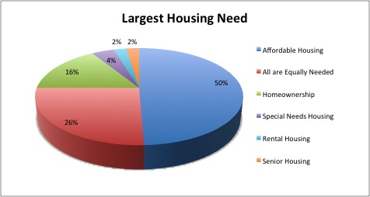
Largest Housing Need
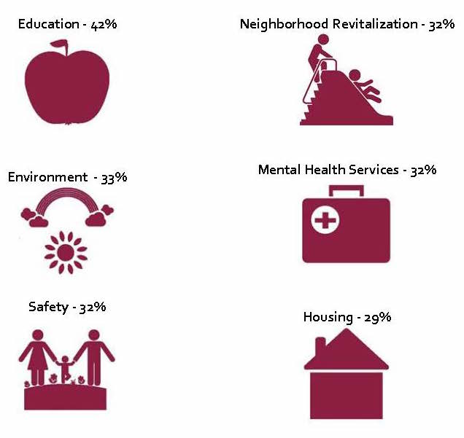
needs 2
5. Summary of public comments
This could be a brief narrative summary or reference an attached document from the Citizen Participation section of the Con Plan.
The only comments received were at the Public Hearing. A recording of the meeting is available upon request. HCD Staff took notes as did all the Mayors during the public comment process. Agencies were there to thank the Mayor's for the committee recommendations or to ask the Mayors to reconsider the committee recommendations if they had not been recommended for funding. All agencies provided information about their program and the services they provide to low income residents of the county.
6. Summary of comments or views not accepted and the reasons for not accepting them
All comments were accepted, reviewed and considered during the deliberations of the Mayor and the Policy board made up of all the Mayors from the cities within the Urban County.

7. Summary
Salt Lake County continued the process of having all CDBG funds pooled and distributed through a collaborative decision-making process. Under this process, applicants, including both non-profit service providers and local jurisdictions, apply for funding through an application process through the County's Grantor Management System. The Citizen Participation Process has been amended to include three citizen review committees that better represent the various program areas, who then score and rank the applications for each program. The County holds a joint public hearing including the Mayors of all the Urban County participating jurisdictions to solicit public input on the preliminary budget recommendations from the citizen committees. Following the public hearing, the approval body will either consent to the preliminary budget, or in consultation with the Salt Lake County Mayor, recommend modifications to it. Upon receiving the final budget recommendation of the approval body, final approval will be made by the Salt Lake County Mayor.
This process has created a more streamlined, efficient and effective grant process for all involved and has enabled the County to collectively have a greater impact to the challenges we seek to address. The format of the Community & Economic Development Advisory Council (CEDAC) was changed to include citizens from the participating Cities, the Metro Townships and the unincorporated areas of the County to assist with the collaboration of the priorities. The HOME Program review committee is made up of Consortium City representatives and citizen volunteers; and the Community & Support Services Board is made up of citizen volunteers and representatives from financial institutions that are responsible for Community Reinvestment programs.

Amendment: Included in this submittal is the planned use of COVID 19 CDBG funds received by South Jordan and the reallocation of HOME funds to help with the impact of the covid by increasing funding for UCA by $257,000 and increasing funding for housing connect by $489,000 to fund shorter term rental assistance.

PR-05 Lead & Responsible Agencies - 91.200(b)
1. Agency/entity responsible for preparing/administering the Consolidated Plan
The following are the agencies/entities responsible for preparing the Consolidated Plan and those responsible for administration of each grant program and funding source.
Agency Role | Name | Department/Agency
Lead Agency | SALT LAKE COUNTY

CDBG Administrator | SALT LAKE COUNTY | Salt Lake County Housing & Community Development
HOPWA Administrator
HOME Administrator | SALT LAKE COUNTY | Salt Lake County Housing & Community Development
ESG Administrator | SALT LAKE COUNTY | Salt Lake County Housing & Community Development
HOPWA-C Administrator
Table 1 – Responsible Agencies

Narrative
Salt Lake County Division of Housing and Community Development is responsible for the management of the CDBG, HOME and ESG programs.

Consolidated Plan Public Contact Information
Consolidated Plan Public Contact Information
Randy Jepperson, 385-468-4886, rjepperson@slco.org

AP-10 Consultation - 91.100, 91.200(b), 91.215(l)
1. Introduction
Salt Lake County has updated its Citizen Participation Plan to reflect the changes in the Urban County process for the CDBG funds. This Plan helps determine and prioritize the needs of the communities within the County’s jurisdiction and involves the public in the Consolidated Plan process. The current document is available on our web page at: http://slco.org/community-resources/plans-and-reports/
In October 2013, Salt Lake County Housing and Community Development completed a community needs assessment to gain a better understanding of the community needs of low to moderate-income households in Salt Lake County, Utah. The purpose of the project was to help inform the allocation of limited resources, thru Community Development Block Grant (CDBG), Social Services Block Grant (SSBG), Emergency Solutions Grant (ESG) and (HOME) Home Investment Partnership Program grant funding, to organizations whose programs can best address the needs of low to moderate-income households in Salt Lake County, Utah. Starting in October 2016 a new Needs Assessment was started to continue defining the needs in the community. The process was completed in August 2017 and data utilized for the 2017-18 and 2018-19 grant processes.
Provide a concise summary of the jurisdiction’s activities to enhance coordination between public and assisted housing providers and private and governmental health, mental health and service agencies (91.215(l)).
This year we continued existing partnerships but worked more directly with the State Department of Workforce Services specifically the Office of Housing and Homeless Division, Shelter the Homeless Inc., and with the Utah State Legislature. Consultations continue to be held with the Housing Authority of the County of Salt Lake, West Valley City Housing Authority, Salt Lake Valley Habitat for Humanity, Community Development Corporation of Utah, Utah Community Action Program, Assist Inc., as well as advocates for the disabled, seniors and the homeless. Included in this process were representatives from all the Jurisdictions of the Urban County as well as the HOME Consortium Cities.
Describe coordination with the Continuum of Care and efforts to address the needs of homeless persons (particularly chronically homeless individuals and families, families with children, veterans, and unaccompanied youth) and persons at risk of homelessness.
In 2014, the Continuum of Care adopted the Collective Impact Model for the homeless housing and services system and selected Salt Lake County Government as the backbone agency within that model. As part of those duties, Salt Lake County Government also became the Collaborative Applicant for the UT-500 Continuum of Care.
In 2015, Salt Lake County’s Mayor developed a Collective Impact Steering Committee on Homelessness. The Steering Committee is focused on improving the homeless housing and service delivery system in Salt Lake County in order to better meet the needs of homeless persons and persons at risk of homelessness. The focus is to provide housing and services as quickly as possible to those who are homeless. The goal is to have the homeless housing and services solutions to be system-oriented rather than agency-oriented and to promote engagement rather than enablement. The collective expertise, resources and data are used to continuously improve the homeless housing and services system so everyone is safe, integrated, efficient and focused on self-sufficiency.
The County has developed a process for Consumer Participation in funding decisions for Emergency Solutions Grant funds.
Describe consultation with the Continuum(s) of Care that serves the jurisdiction’s area in determining how to allocate ESG funds, develop performance standards for and evaluate outcomes of projects and activities assisted by ESG funds, and develop funding, policies and procedures for the operation and administration of HMIS
Working with the Continuum of Care (CoC) the County has provided better coordination for efforts to align services for homeless individuals and families and those at eminent risk of becoming homeless. In Salt Lake County there are three ESG funding sources: Salt Lake City, Salt Lake County, and the State of Utah. These three government agencies meet regularly to discuss homeless and housing issues, including ESG: funding allocations, performance standards, and outcome evaluations. In addition, a nine member Prioritization Committee is responsible for a rank and review of all UT-500 project applications for Continuum of Care funds. Prioritization Committee members include representatives from the three ESG funding sources as well as agencies that provide mental health and behavioral health services at the County and State level, and homeless or formerly homeless consumer representation. Funding coordination, performance standards, and outcome evaluation are among the criteria used to rank project applications.
The State of Utah is the Lead HMIS agency for the UT-500 Continuum of Care. Oversight for the Lead HMIS agency is provided by the HMIS Steering Committee. The Steering Committee includes, among others, representatives from the Continuum of Care as well as ESG funders from Salt Lake City, Salt Lake County, and the State of Utah. The HMIS Steering Committee meets monthly to discuss topics including HMIS funding and updates to the HMIS Standard Operating Procedures as well as needs of the providers and funding agencies. Salt Lake County convenes a regular government grants coordination meeting with city government representatives to coordinate activities and provide training opportunities. In addition, Salt Lake County is represented on the Collective Impact Homeless Committee, a broad-based stakeholder group, which discusses and collaborates on all issues related to homelessness.
2. Agencies, groups, organizations and others who participated in the process and consultations

Table 2 – Agencies, groups, organizations who participated
1 | Agency/Group/Organization | HOUSING AUTHORITY OF THE COUNTY OF SALT LAKE
 | Agency/Group/Organization Type | Housing  PHA  Services - Housing  Services-Elderly Persons
 | What section of the Plan was addressed by Consultation? | Public Housing Needs  Homeless Needs - Chronically homeless  Homeless Needs - Families with children  Homelessness Needs - Veterans  Homelessness Needs - Unaccompanied youth
 | Briefly describe how the Agency/Group/Organization was consulted. What are the anticipated outcomes of the consultation or areas for improved coordination? | The combined funding process continues where all CDBG, ESG and SSBG funds are pooled and distributed through a collaborative decision-making process. Under this new process, applicants, including both non-profit service providers and local jurisdictions, apply for funding through an RFA process. The Citizen Participation Process has been amended to include a citizen review committee that better reflects the various jurisdictions to score and rank the various applications. The County holds a joint public hearing to solicit public input on the preliminary budget recommendations from the citizen committees. Following the public hearing, the approval body will either consent to the preliminary budget, or in consultation with the County Mayor, recommend modifications to it. Upon receiving the final budget recommendation of the approval body, final approval will be made and submitted to HUD.
2 | Agency/Group/Organization | COMMUNITY DEVELOPMENT CORPORATION OF UTAH
 | Agency/Group/Organization Type | Housing  Services - Housing  Service-Fair Housing  Community Development Financial Institution
 | What section of the Plan was addressed by Consultation? | Housing Need Assessment  Lead-based Paint Strategy
 | Briefly describe how the Agency/Group/Organization was consulted. What are the anticipated outcomes of the consultation or areas for improved coordination? | We meet weekly with CDCU on the status of projects and ask for their input on needs identified in the community.
3 | Agency/Group/Organization | ASSIST INC
 | Agency/Group/Organization Type | Housing  Services - Housing  Services-Elderly Persons  Services-Persons with Disabilities
 | What section of the Plan was addressed by Consultation? | Housing Need Assessment  Lead-based Paint Strategy
 | Briefly describe how the Agency/Group/Organization was consulted. What are the anticipated outcomes of the consultation or areas for improved coordination? | We meeting monthly with Assist Inc. about projects and needs of the community.
4 | Agency/Group/Organization | Salt Lake Valley Habitat for Humanity
 | Agency/Group/Organization Type | Housing  Services - Housing  Service-Fair Housing
 | What section of the Plan was addressed by Consultation? | Housing Need Assessment  Market Analysis  Anti-poverty Strategy  Lead-based Paint Strategy
 | Briefly describe how the Agency/Group/Organization was consulted. What are the anticipated outcomes of the consultation or areas for improved coordination? | We meet weekly with Salt Lake Valley Habitat for Humanity and go over status of projects and needs in the community.
5 | Agency/Group/Organization | Salt Lake Community Action Program
 | Agency/Group/Organization Type | Housing  Services - Housing  Services-Children  Services-Elderly Persons  Services-Persons with Disabilities  Services-Persons with HIV/AIDS  Services-homeless  Service-Fair Housing  Health Agency
 | What section of the Plan was addressed by Consultation? | Housing Need Assessment  Homeless Needs - Chronically homeless  Homeless Needs - Families with children  Homelessness Needs - Veterans  Homelessness Needs - Unaccompanied youth  Homelessness Strategy  Market Analysis  Anti-poverty Strategy  Lead-based Paint Strategy
 | Briefly describe how the Agency/Group/Organization was consulted. What are the anticipated outcomes of the consultation or areas for improved coordination? | We meet monthly with Utah Community Action on needs in the community.
6 | Agency/Group/Organization | WEST VALLEY CITY
 | Agency/Group/Organization Type | Housing  PHA  Services - Housing  Services-Elderly Persons  Services-Persons with Disabilities
 | What section of the Plan was addressed by Consultation? | Housing Need Assessment  Public Housing Needs  Homeless Needs - Chronically homeless  Homeless Needs - Families with children
 | Briefly describe how the Agency/Group/Organization was consulted. What are the anticipated outcomes of the consultation or areas for improved coordination? | We meet with West Valley City monthly to review status of GHHI projects and status of needs.

Identify any Agency Types not consulted and provide rationale for not consulting
Outreach was made to all known agencies.

Other local/regional/state/federal planning efforts considered when preparing the Plan
Name of Plan | Lead Organization | How do the goals of your Strategic Plan overlap with the goals of each plan?
Continuum of Care | Salt Lake County | Salt Lake County
Consumer Participation-Process & Procedures | Salt Lake County | SL Co. updated process and procedures for all Community & Support Services to include consumer input to ensure the process is effective an impactful for the clients being served. Specific to ESG, the policies have been approved by our Regional HUD Office. This process includes the participation of homeless and formerly homeless individuals in the planning process for grant funding as well as in the funding recommendation process.
Table 3 - Other local / regional / federal planning efforts

Narrative
The combined process has created a more streamlined, efficient and effective grant process for all involved and enables the County to collectively have a greater impact on the challenges we seek to address.
The Salt Lake County policy related to Consumer Participation in funding decisions for Emergency Solutions Grant funds is described in the ESG Operating Standards and has been approved by the Region 8 Office of HUD.
Salt Lake County has developed and implemented a plan to consult with homeless or formerly homeless individuals in the policy and decision-making process for facilities, services and/or other assistance that receives funds under the Emergency Solutions Grant.
HCD staff will work with partners in the CoC and the Collective Impact Steering Committee to identify 4 or more homeless or formerly homeless individuals to participate in the annual cycle for the allocation of ESG grant funds. This process is facilitated by the citizen advisory committee known as the Community & Support Services Advisory Council (CSSAC). The homeless or formerly homeless individuals will have the opportunity to review the applications for funding for projects that are proposed to serve homeless individuals, they will be asked to independently score and rank those proposals. These scores and input will be factored into the final scores and ranking for each application. Homeless participants will be invited to attend the CSSAC weekly discussions, however, the attendance requirement imposed on CSSAC members will not be applicable to the homeless representatives. HCD staff will ensure that homeless or formerly participants are able to share their perspectives and comments on each grant application for homeless services via alternative methods, such as participation in focus groups onsite at locations where homeless services are offered. At least one discussion will be scheduled at a place and time which is most convenient and accessible for the homeless representatives to attend in person.
HCD staff will work with its partners in the CoC and the Collective Impact Steering Committee to conduct targeted outreach to one or more homeless or formerly homeless individuals from each of the subpopulations identified by the Collective Impact Steering Committee (i.e. families with children, transitional aged youth, single men and women, veterans, domestic violence victims, individuals with behavioral health disorders, individuals who are medically frail/terminally ill, individuals exiting prison or jail, unsheltered homeless). Individuals will be invited to participate in an annual needs assessment specific to homeless services. The objective will be to identify the services that are considered a priority by those individuals who benefit from them, and to determine gaps in availability and/or barriers to access. In the event that similar studies are conducted by community partners which consult directly with homeless or formerly homeless individuals, the conclusions of the related reports will be incorporated into the summary findings by HCD staff. A summary of the input provided by homeless or formerly homeless individuals will be presented annually to the Salt Lake County Mayor for his/her review and consideration prior to the deliberations which will result in the final funding decisions.

AP-12 Participation - 91.401, 91.105, 91.200(c)
1. Summary of citizen participation process/Efforts made to broaden citizen participation
Summarize citizen participation process and how it impacted goal-setting

Salt Lake County held a public hearing with legal notice, on April 17, 2019, to get input on needs in the community and notify the public of funding availability estimated timelines.
Salt Lake County made available with legal notice (published 3/31/19) of the Draft 2019-20 Action Plan, 2017-2018 CAPER and proposed funding recommendations and Public Hearing date. The legal notice was available in both English and Spanish. All documents were available for public comment from March 31 to May 3, 2019 on the County's website as well as in the HCD Office. The County facility is fully accessible to people with disabilities. Notice was provided of the opportunity for accommodations if needed. A Press Release was sent out from the Mayor's office, Notice was included in the Diversity Website newsletter; announcement was sent to the Housing Coalition to include in their newsletter, and an email was sent to the County list of interested agencies.
A public hearing was held April 17, 2019, thirty agencies sent representatives and provided comments on the proposed action plan and use of funds. From the input received, review of the needs assessment, Salt Lake County Mayor and the Mayor of the cities of Salt Lake Countymade the final decision on how the CDBG, HOME and ESG funds will be allocated. Notification went out to agencies on May 7, 2019.

Citizen Participation Outreach
Sort Order | Mode of Outreach | Target of Outreach | Summary of  response/attendance | Summary of  comments received | Summary of comments not accepted and reasons | URL (If applicable)
1 | Newspaper Ad | Minorities  Non-English Speaking - Specify other language: hispanic  Persons with disabilities  Non-targeted/broad community  Residents of Public and Assisted Housing | no comments or input was received | no comments or input was received | no comments or input was received
2 | Newspaper Ad | Minorities  Non-English Speaking - Specify other language: hispanic  Persons with disabilities  Non-targeted/broad community  Residents of Public and Assisted Housing | notification through paper | no comments were received | no comments were received
3 | Public Hearing | Minorities  Non-English Speaking - Specify other language: hispanic  Persons with disabilities  Non-targeted/broad community  Residents of Public and Assisted Housing | 60 agencies attended the hearing and gave input on the recommendations for funding | We have a recording of the meeting | All comments were received
Table 4 – Citizen Participation Outreach

Expected Resources

AP-15 Expected Resources - 91.420(b), 91.220(c)(1,2)
Introduction
Salt Lake County has allocated CDBG, HOME and ESG funds to fund activities which will help meet the needs identified. Salt Lake County will provide a HOME match from general funds for $200,000. Salt Lake County has sufficient excess match from previous years to meet the remaining $216,037 requirement.
This amendment includes two changes, the first is increasing the amount of funds for tbra out of the current grant and the other is adding to the source of funding the stimulus funds received from CDBG and ESG. Round #2 ESG-CV funds and Round #3 CDBG-CV funds added on 2/12/2021.
Anticipated Resources
Program | Source of Funds | Uses of Funds | Expected Amount Available Year 1 |  |  |  | Expected Amount Available Remainder of ConPlan  $ | Narrative Description
 |  |  | Annual Allocation: $ | Program Income: $ | Prior Year Resources: $ | Total:  $
CDBG | public - federal | Acquisition  Admin and Planning  Economic Development  Housing  Public Improvements  Public Services | 2,478,922 | 50,000 | 536,079 | 3,065,001 | 0 | This includes the grant allocation and recaptured funds from actitivies from prior years. The program income for economic development revolving loan funds are anticipated only.
HOME | public - federal | Acquisition  Homebuyer assistance  Homeowner rehab  Multifamily rental new construction  Multifamily rental rehab  New construction for ownership  TBRA | 1,632,267 | 1,300,000 | 1,091,743 | 4,024,010 | 0 | This includes the grant allocation, program income received from activies as well as recaptured funds from prior year activities.
ESG | public - federal | Conversion and rehab for transitional housing  Financial Assistance  Overnight shelter  Rapid re-housing (rental assistance)  Rental Assistance  Services  Transitional housing | 214,436 | 0 | 0 | 214,436 | 0 | This is the grant allocation of ESG funds.
Other | public - federal | Admin and Planning  Economic Development  Homebuyer assistance  Housing  Public Services  Rapid re-housing (rental assistance)  Rental Assistance  TBRA  Other | 2,790,850 | 0 | 0 | 2,790,850 | 2,790,850 | Allocation of Round #1 CDBG-CV funds ($1,487,703) & Round #3 CDBG-CV funds ($1,303,147) to be used to prevent, prepare for and respond to the Coronavirus.
Other | public - federal | Overnight shelter  Public Services  Rapid re-housing (rental assistance)  Rental Assistance  Services  TBRA  Other | 3,132,150 | 0 | 0 | 3,132,150 | 3,132,150 | Allocation of Round #1 ESG-CV funds ($751,093) and Round #2 ESG-CV funds ($2,381,057) to be used to prevent, prepare for and respond to the Coronavirus.
Table 1 - Expected Resources – Priority Table

Explain how federal funds will leverage those additional resources (private, state and local funds), including a description of how matching requirements will be satisfied
Salt Lake County will provide $200,000 from county general funds to help meet the match requirements of the HOME program. Salt Lake County will also provide the required 100% match for the ESG program through matching funds from each of the Subgrantees as well as through general funds for the administration of the program.
If appropriate, describe publically owned land or property located within the jurisdiction that may be used to address the needs identified in the plan
None.
Discussion
Salt Lake County will work with partners to make the best use of the funds allocated as the year progresses. We will provide active contract management to assist agencies meet their expected indicators moving toward achieveing their outcomes. The focus is to be able to measure the impact of the funded programs and projects on the lives of the residents of Salt Lake County.

Annual Goals and Objectives
AP-20 Annual Goals and Objectives - 91.420, 91.220(c)(3)&(e)
Goals Summary Information
Sort Order | Goal Name | Start Year | End Year | Category | Geographic Area | Needs Addressed | Funding | Goal Outcome Indicator
1 | Decent Housing H-1: Housing Rehab & Accessibility | 2015 | 2019 | Affordable Housing | Salt Lake County | Housing Opportunities | CDBG: $595,000  HOME: $1,016,688 | Homeowner Housing Rehabilitated: 281 Household Housing Unit
2 | Housing H-3: Social Services-Stability & Safety | 2015 | 2019 | Homeless  Non-Homeless Special Needs  Non-Housing Community Development | Salt Lake County | Stability and Safety | CDBG: $213,493 | Public service activities other than Low/Moderate Income Housing Benefit: 1495 Persons Assisted
3 | Decent Housing Homeless-2: Rental Assistance-RRH | 2015 | 2019 | Affordable Housing | Salt Lake County | Rental Assistance - Rapid Re-Housing | HOME: $1,246,457  ESG: $79,770 | Tenant-based rental assistance / Rapid Rehousing: 250 Households Assisted
4 | Decent Housing H-7: Senior Housing | 2015 | 2019 | Affordable Housing | Salt Lake County | Increase Rental Housing | HOME: $0 | Rental units constructed: 58 Household Housing Unit
5 | Decent Housing H-2: Homeownership | 2015 | 2019 | Affordable Housing | Salt Lake County | Homeownership | CDBG: $287,933  HOME: $163,000 | Direct Financial Assistance to Homebuyers: 157 Households Assisted
6 | Housing H-5: Social Services-Econ Independence | 2015 | 2019 | Non-Housing Community Development | Salt Lake County | Economic Independence | CDBG: $115,456  HOME: $0  ESG: $0 | Public service activities other than Low/Moderate Income Housing Benefit: 62 Persons Assisted
7 | Decent Housing Homeless and Special Needs -3 | 2015 | 2019 | Affordable Housing | Salt Lake County | Access to Crisis Services  Rental Assistance - Rapid Re-Housing | CDBG: $0  HOME: $1,780,000  ESG: $0 | Rental units constructed: 119 Household Housing Unit  Rental units rehabilitated: 95 Household Housing Unit  Other: 0 Other
8 | Sustainable Living Environment CD-2 Infrastructure | 2015 | 2019 | Non-Housing Community Development | Salt Lake County | Infrastructure Improvements | CDBG: $667,829 | Public Facility or Infrastructure Activities other than Low/Moderate Income Housing Benefit: 2950 Persons Assisted
10 | Economic Opportunity & Job Creation | 2015 | 2019 | Non-Housing Community Development | Salt Lake County | Creating Economic Opportunity | CDBG: $50,000 | Jobs created/retained: 5 Jobs  Businesses assisted: 1 Businesses Assisted
11 | Housing H-4: Social Services-Access to Crisis Serv | 2015 | 2019 | Non-Housing Community Development | Salt Lake County | Access to Crisis Services | CDBG: $50,127  ESG: $119,655 | Public service activities for Low/Moderate Income Housing Benefit: 396 Households Assisted  Homeless Person Overnight Shelter: 1955 Persons Assisted
12 | Sustainable Living Environment CD-3 Public Fac. | 2015 | 2019 | Homeless  Non-Homeless Special Needs  Non-Housing Community Development | Salt Lake County | Public Facilities Improvements | CDBG: $685,163 | Public Facility or Infrastructure Activities other than Low/Moderate Income Housing Benefit: 6299 Persons Assisted
13 | Decent Housing H-6: Rental Housing | 2015 | 2019 | Affordable Housing | Salt Lake County | Increase Rental Housing | HOME: $1,433,543 | Rental units constructed: 290 Household Housing Unit  Rental units rehabilitated: 95 Household Housing Unit
Table 2 – Goals Summary

Goal Descriptions

1 | Goal Name | Decent Housing H-1: Housing Rehab & Accessibility
 | Goal Description | HOME funds will fund the GHHI program. CDBG funds will be used to fund the GHHI through Community Development Corporation, an Emergency Repair Program through Assist, Inc., and project delivery for the County's loan program. Salt Lake County received an allocation of $750,000 from the Federal Home Loan Bank of Des Moines Iowa. These funds will leverage HOME funds to help do a complete retrofit of 35 homes, to enable the elderly and those with disabilities to remain in their home by making the home fully accessible, visitable, healthy and safe. HOME funds will go to CDCU $200,000, Salt Lake Valley Habitat for Humanity $400,000 and for West Valley City and Taylorsville $416,600
2 | Goal Name | Housing H-3: Social Services-Stability & Safety
 | Goal Description | CDBG & ESG funds awarded funding were required to clearly illustrate that an eligible funded service will result in a beneficial change in the life of a low-moderate income person, as measured by one of the designated performance indicators and that in due course the impact will be directly linked to one of the following outcomes:  Individuals and Families to be Stabilized and Safe  Activities included First Step House Housing Case Management, South Valley Sanctuary, and The INN Between
3 | Goal Name | Decent Housing Homeless-2: Rental Assistance-RRH
 | Goal Description | HOME will be provided for short term rental assistance for 150 households. ESG funds will provide Rapid Re-Housing for more than 116 households. It is estimated through these programs up to 250 households will be assisted.
4 | Goal Name | Decent Housing H-7: Senior Housing
 | Goal Description | No funding is allocated to this activity
5 | Goal Name | Decent Housing H-2: Homeownership
 | Goal Description | $50,000 of HOME funds will be used to provide downpayment assistance in the cities of South Jordan, Sandy and West Jordan. Taylorsville City commits $36,000 and West Valley City commits $77,000 to fund their down payment assistance program.  $287,933 of CDBG funds will be used to provide down payment assistance through CDCU and IRC.
6 | Goal Name | Housing H-5: Social Services-Econ Independence
 | Goal Description | CDBG funds awarded funding were required to clearly illustrate that an eligible funded service will result in a beneficial change in the life of a low-moderate income person, as measured by one of the designated performance indicators and that in due course the impact will be directly linked to one of the following outcomes:  - Individuals and Families to be Self-Supported through Sufficient Earnings  - Dependency to be Reduced or Eliminated  Agencies to receive funding include Columbus Foundation and International Rescue Committee-Spice Kitchen
7 | Goal Name | Decent Housing Homeless and Special Needs -3
 | Goal Description | CDBG & ESG programs, that were awarded funding, were required to clearly illustrate that an eligible funded service will result in a beneficial change in the life of a low-moderate income person, as measured by one of the designated performance indicators and that in due course the impact will be directly linked to one of the following outcomes:  - Homeless to be Housed  - Choice in Housing Option
8 | Goal Name | Sustainable Living Environment CD-2 Infrastructure
 | Goal Description | Projects submitted under Infrastructure Improvements must be located within a CDBG eligible census tract area with the exception of ADA Improvements. ADA Improvements can be made anywhere in the Urban County.  CDBG funds will be used for the Midvale ADA Improvement Project, South Salt Lake Street Lighting Project, Millcreek City Park Project, and the Kearns Sidewalk Project. These projects include infrastructure improvements in residential neighborhoods and underserved areas.  * Neighborhood Revitalization
10 | Goal Name | Economic Opportunity & Job Creation
 | Goal Description | CDBG Funds may be utilized to provide loans through the Economic Development Revolving Loan Fund to businesses that will be unbankable to create economic opportunity and to create jobs for low and moderate income residents in the Urban County. Funds would come through anticipated program income.
11 | Goal Name | Housing H-4: Social Services-Access to Crisis Serv
 | Goal Description | CDBG & ESG funds awarded funding were required to clearly illustrate that an eligible funded service will result in a beneficial change in the life of a low-moderate income person, as measured by one of the designated performance indicators and that in due course the impact will be directly linked to one of the following outcomes:  - Access to Crisis Service  Agencies receiving funding include Rape Recovery Center, The Road Home and YWCA
12 | Goal Name | Sustainable Living Environment CD-3 Public Fac.
 | Goal Description | - CDBG funds will be used for Facility Improvements: which include improvements to facilities that provide services or housing for low and moderate income persons.  - CDBG funds will also be used for Facility Improvements to agencies that provide Access to Crisis Services/Stability and Safety:  - Projects for improvements to facilities that provide services or housing for special needs households or individuals.  - Funding will be provided to the following agencies for improvements: Columbus Foundation, First Step House, House of Hope, Odyssey House, Work Activity Center, South Valley Sanctuary, The INN Between, and Wasatch Homeless Healthcare dba Fourth Street Clinic
13 | Goal Name | Decent Housing H-6: Rental Housing
 | Goal Description | $900,0000 of HOME funds is committed to the Lincoln Towers purchase and rehabilitation of an existing 95 rental unit project for the homeless. $300,000 fo HOME funds is committed to the two phases of the 2255 South project.

AP-35 Projects - 91.420, 91.220(d)
Introduction
Salt Lake County has identified these projects to meet the goals of the Consolidated Plan for the year 2019-20. Activities are included under each project as appropriate. The special allocation of CARES Act funds, including CDBG-CV and ESG-CV, have been included in this Action Plan as instructed by HUD.
# | Project Name
1 | 01- CDBG Affordable Housing
2 | 01- CDBG Housing Improvement Program
4 | 02 & 05 - CDBG Public Infrastructure and Public Works
5 | 08- CDBG Private Non-Profit Facility Improvements
6 | 09 - CDBG Private Non-Profit Public Services
8 | 10- CDBG Economic Development
10 | HOME Rental Housing
11 | HOME Tenant Based Rental Assistance
12 | CHDO set aside rental housing
13 | HOME Homeownership
14 | HOME Housing rehabilitation
15 | HESG19 Salt Lake County
16 | Action Plan Administration - HOME Administration
17 | Action Plan Administration (CDBG)
18 | CV-CARES Act CDBG CXL THIS PROJECT
19 | HESG20 - Salt Lake County
20 | CV-CARES Act CDBG Public Services
Table 3 – Project Information

Describe the reasons for allocation priorities and any obstacles to addressing underserved needs
The funding was allocated according to the needs identified in the community. The needs of the community greatly exceed the funding available to mitigate them.

AP-38 Project Summary
Project Summary Information

1 | Project Name | 01- CDBG Affordable Housing
 | Target Area | Salt Lake County
 | Goals Supported | Decent Housing H-1: Housing Rehab & Accessibility  Decent Housing H-2: Homeownership
 | Needs Addressed | Housing Opportunities  Homeownership
 | Funding | CDBG: $287,933
 | Description | Funds may be allocated to activities that provide Home Ownership through Down Payment Assistance and Property Acquisition for Housing Development.
 | Target Date
 | Estimate the number and type of families that will benefit from the proposed activities
 | Location Description
 | Planned Activities | # 3484 - LMH -13A - Down Payment Assistance will be provided through Community Development Corporation of Utah - Down Payment Assistance Program $220,000.00  #3485 LMH - 13 - Down Payment Assistance will be provided through the International Rescue Committee - Supporting Stable Families: Homeownership Assistance for Refugees in Salt Lake County. $67,933.00
2 | Project Name | 01- CDBG Housing Improvement Program
 | Target Area | Salt Lake County
 | Goals Supported | Decent Housing H-1: Housing Rehab & Accessibility
 | Needs Addressed | Housing Opportunities  Stability and Safety
 | Funding | CDBG: $595,000
 | Description | Housing Rehabilitation, Emergency Home Repair Program and Accessibility Improvements to single-family homes. CDBG activities will include Assist, Inc. Emergency Home Repair Program and Accessibility; Community Development Corporation GHHI and Project Delivery for Housing and Community Development for Rehab projects and loan servicing.
 | Target Date
 | Estimate the number and type of families that will benefit from the proposed activities
 | Location Description
 | Planned Activities | #3486 - LMH - 14A - Assist, Inc. Community Design Center -Housing Rehab & Accessibility $400,000.00  #3487 - LMH - 14A- Community Development Corporation of Utah - GHHI $125,000.00
3 | Project Name | 02 & 05 - CDBG Public Infrastructure and Public Works
 | Target Area | Salt Lake County
 | Goals Supported | Sustainable Living Environment CD-2 Infrastructure
 | Needs Addressed | Infrastructure Improvements
 | Funding | CDBG: $667,829
 | Description | Infrastructure Improvements including streets, sidewalks, parks, etc.
 | Target Date
 | Estimate the number and type of families that will benefit from the proposed activities
 | Location Description
 | Planned Activities | #3496 - LMA - 03K - City of South Salt Lake - West Temple from 3700 South to 4500 South $125,000.00  #3497- LMA - 03L - Greater Salt Lake Municipal Services District 4835 S, 4580 W, 4805 S Loop Sidewalk $242,829.00.  #3498- LMA- O3L - Midvale City Corporation ADA Improvement Program $150,000.00  #3499 - LMA - 03F - Millcreek City Sunnyvale Park Improvements $150,000.00
4 | Project Name | 08- CDBG Private Non-Profit Facility Improvements
 | Target Area | Salt Lake County
 | Goals Supported | Sustainable Living Environment CD-3 Public Fac.
 | Needs Addressed | Public Facilities Improvements
 | Funding | CDBG: $685,163
 | Description | Funds will be utilized to provide improvements to facilities utilized by Non-Profit Agencies that provide services to homeless and/or low- and moderate-income people. Funds may also be used for engineering and architectural needs for new homeless facility resource centers.
 | Target Date
 | Estimate the number and type of families that will benefit from the proposed activities
 | Location Description
 | Planned Activities | #3488 - LMC - 03B - Columbus Foundation, Inc. - Columbus Roofing Project Main Campus and Activities Building- $80,00  #3489 - LMC - 03Z - First Step House. - 411 North Grant Street Facility Improvement Project- $105,915.00  #3490 - LMC - 03Z - House of Hope Paint Repair Project- $45,000  #3491 - LMC - 03B Odyssey House- Inc. Millcreek Residential Roof Replacement - $49,248.00  #3492 - LMC - 03C South Valley Sanctuary SVS HVAC - $65,000.00  #3493 - LMC - 03C The INN Between Temporary Housing for Terminally Ill and Medically Frail Homeless (Facility Improvement) - $155,000.00  #3494 - LMC - 03B The Work Activity Center, Inc. Fitness Center for Individuals with Disabilities Expansion - $60,000.00  #3495 - LMC - 03C Wasatch Homeless Healther Care, Inc. dba Fourth Street Clinic Waiting Room Renovations - $125,000.00
5 | Project Name | 09 - CDBG Private Non-Profit Public Services
 | Target Area | Salt Lake County
 | Goals Supported | Housing H-3: Social Services-Stability & Safety  Housing H-4: Social Services-Access to Crisis Serv  Housing H-5: Social Services-Econ Independence
 | Needs Addressed | Access to Crisis Services  Economic Independence  Stability and Safety
 | Funding | CDBG: $379,076
 | Description | Funds will be used to provide assistance to Non-Profit agencies to provide services that meet specific outcomes identified through the Needs Assessment and the County Goals and Priorities.
 | Target Date
 | Estimate the number and type of families that will benefit from the proposed activities
 | Location Description
 | Planned Activities | #3503 - LMC - 05H - Columbus Foundation Community Employment Program $57,728.00  #3504 - LMC - 05F - First Step House Case Management Program $86,061.00  #3505 - LMC - 05H - International Rescue Committee Scaling SPICE $57,728.00  #3506 - LMC - 05G - Rape Recover Center Stabilization Healing Services for Survivors of Sexual Violence $50,127.00  #3507 - LMC - 05G - South Valley Sanctuary DV Homeless Shelter & Stabilization Services $44,634.00  #3508 - LMC - 03T - The INN Between Temporary Housing for Terminally Ill & Medically Frail Homeless (Operations) $82,798.00
6 | Project Name | 10- CDBG Economic Development
 | Target Area | Salt Lake County
 | Goals Supported | Economic Opportunity & Job Creation
 | Needs Addressed | Economic Independence  Creating Economic Opportunity
 | Funding | CDBG: $50,000
 | Description | Activities will provide assistance to for-profit businesses to create jobs and provide economic opportunities in the County. These funds would come from program income from loan repayments and are not included in the total budget.
 | Target Date
 | Estimate the number and type of families that will benefit from the proposed activities
 | Location Description
 | Planned Activities | We have the Economic Development Revolving Loan Fund that is funded with existing Program Income. Funds will be allocated as loans are presented and approved by the EDRLF Loan Committee. The Master Participation Agreement has been renewed and the priorities for the program are being reviewed.
7 | Project Name | HOME Rental Housing
 | Target Area | Salt Lake County
 | Goals Supported | Decent Housing H-6: Rental Housing
 | Needs Addressed | Increase Rental Housing
 | Funding | HOME: $1,433,543
 | Description | Rental Housing Projects through the HOME Program, two projects located at 255 south state street (170 units) and the other one located in Sugarhouse Lincoln towers 95 units purchase rehab
 | Target Date
 | Estimate the number and type of families that will benefit from the proposed activities
 | Location Description
 | Planned Activities
8 | Project Name | HOME Tenant Based Rental Assistance
 | Target Area | Salt Lake County
 | Goals Supported | Decent Housing Homeless-2: Rental Assistance-RRH
 | Needs Addressed | Rental Assistance - Rapid Re-Housing
 | Funding | HOME: $1,246,457
 | Description | The Road HOME ($300,000), UCA ($125,000), Housing Connection ($175,000)
 | Target Date
 | Estimate the number and type of families that will benefit from the proposed activities
 | Location Description
 | Planned Activities | Short term rental assistance to prevent homeless, households who have been impacted by the corona virus
9 | Project Name | CHDO set aside rental housing
 | Target Area | Salt Lake County
 | Goals Supported | Decent Housing Homeless and Special Needs -3
 | Needs Addressed | Special Needs Housing
 | Funding | :
 | Description | Cadance ridge sponsored and being developed Neighborworks (formerly Provo) is an eligible CHDO for 2019 funding
 | Target Date
 | Estimate the number and type of families that will benefit from the proposed activities
 | Location Description
 | Planned Activities
10 | Project Name | HOME Homeownership
 | Target Area | Salt Lake County
 | Goals Supported | Decent Housing H-2: Homeownership
 | Needs Addressed | Homeownership
 | Funding | HOME: $165,000
 | Description | Homeownership program will consist of the provision of downpayment assistance South Jordan, Sandy, West Jordan, Taylorsville, and West Valley City
 | Target Date
 | Estimate the number and type of families that will benefit from the proposed activities
 | Location Description
 | Planned Activities
11 | Project Name | HOME Housing rehabilitation
 | Target Area | Salt Lake County
 | Goals Supported | Decent Housing H-1: Housing Rehab & Accessibility
 | Needs Addressed | Housing Opportunities
 | Funding | HOME: $1,016,688
 | Description | Housing rehabilitation
 | Target Date
 | Estimate the number and type of families that will benefit from the proposed activities
 | Location Description
 | Planned Activities
12 | Project Name | HESG19 Salt Lake County
 | Target Area | Salt Lake County
 | Goals Supported | Housing H-3: Social Services-Stability & Safety  Housing H-4: Social Services-Access to Crisis Serv
 | Needs Addressed | Access to Crisis Services  Stability and Safety
 | Funding | ESG: $214,436
 | Description | Funding will be provided to all eligible activities under the HESG program. This includes Emergency Shelter Activities, Rapid Re-Housing, Homeless Prevention (Diversion) and Administration. Administration can not be set up until the grant funds are put into IDIS. These funds must be subfunded and then allocated to an activity.CARES Act ESG-CV funds will also reference this project, as necessary per IDIS guidance. ESG-CV funds will be used to prevent, prepare for, and respond to the coronavirus pandemic (COVID-19) among individuals and families who are homeless or receiving homeless assistance; and to support additional homeless assistance and homelessness prevention activities to mitigate the impacts of COVID-19. Funds will be used for the eligible components of Rapid Re-Housing, Homelessness Prevention, Emergency Shelter, and/or Temporary Shelter, including the activities of rental assistance, housing relocation and stabilization services, shelter operations, and administrative costs.
 | Target Date
 | Estimate the number and type of families that will benefit from the proposed activities
 | Location Description
 | Planned Activities | #3501 - The Road Home - Emergency Shelter Operations $55,917.00  #3500 - The Road Home - RRH $79,770.00  #3501 - YWCA - Women in Jeopardy Program $63,738.00  # - Administration $15,010.52 (can't be set up in IDIS until grant funds are received.)
13 | Project Name | Action Plan Administration - HOME Administration
 | Target Area | Salt Lake County
 | Goals Supported | Decent Housing H-6: Rental Housing
 | Needs Addressed | Housing Opportunities  Homeownership  Increase Rental Housing  Special Needs Housing
 | Funding | HOME: $162,322
 | Description | Funds will be used to administer the HOME Investment Partnership Grant
 | Target Date
 | Estimate the number and type of families that will benefit from the proposed activities
 | Location Description
 | Planned Activities
14 | Project Name | Action Plan Administration (CDBG)
 | Target Area | Salt Lake County
 | Goals Supported | Decent Housing H-1: Housing Rehab & Accessibility  Decent Housing H-2: Homeownership  Housing H-3: Social Services-Stability & Safety  Housing H-4: Social Services-Access to Crisis Serv  Housing H-5: Social Services-Econ Independence  Sustainable Living Environment CD-2 Infrastructure  Sustainable Living Environment CD-3 Public Fac.  Economic Opportunity & Job Creation
 | Needs Addressed | Housing Opportunities  Access to Crisis Services  Homeownership  Economic Independence  Stability and Safety  Infrastructure Improvements  Public Facilities Improvements  Creating Economic Opportunity
 | Funding | CDBG: $400,000
 | Description | Funds will be used to administer the CDBG Programs.
 | Target Date
 | Estimate the number and type of families that will benefit from the proposed activities
 | Location Description
 | Planned Activities | #3502 21A CDBG Admin Funds $400,000.00
15 | Project Name | CV-CARES Act CDBG CXL THIS PROJECT
 | Target Area | Salt Lake County
 | Goals Supported | Decent Housing H-2: Homeownership  Housing H-3: Social Services-Stability & Safety  Housing H-5: Social Services-Econ Independence  Decent Housing Homeless-2: Rental Assistance-RRH  Decent Housing Homeless and Special Needs -3
 | Needs Addressed | Access to Crisis Services  Homeownership  Economic Independence  Rental Assistance - Rapid Re-Housing
 | Funding | :
 | Description | Salt Lake County will allocate the CDBG-CV funds of $2,790,850 to provide grants to agencies to support housing stability for low-to-moderate income residents of Salt Lake County whose housing has been threatened by the economic impacts of the coronavirus pandemic (COVID-19), and the associated administrative costs.
 | Target Date
 | Estimate the number and type of families that will benefit from the proposed activities
 | Location Description
 | Planned Activities | Salt Lake County will release a request for applications to possibly fund public service activities including housing case management or related staffing costs, as necessary for agencies to have the capacities to administer various sources of rent payments or other assistance to prevent homelessness. Salt Lake County will also fund public services activities of up to six months of emergency assistance for basic services such as food or shelter, including payment for rent or utilities, when administered in conjunction with monthly housing case management for evaluation of ongoing need for assistance.
16 | Project Name | HESG20 - Salt Lake County
 | Target Area | Salt Lake County
 | Goals Supported | Housing H-3: Social Services-Stability & Safety  Housing H-4: Social Services-Access to Crisis Serv  Decent Housing Homeless-2: Rental Assistance-RRH  Decent Housing Homeless and Special Needs -3
 | Needs Addressed | Access to Crisis Services  Rental Assistance - Rapid Re-Housing  Stability and Safety
 | Funding | ESG: $217,817  CARES act esg: $3,132,150
 | Description | Funding will be provided to all eligible activities under the HESG program. This includes Emergency Shelter Activities, Rapid Re-Housing, Homeless Prevention (Diversion) and Administration.ESG-CV funds will be used to prevent, prepare for, and respond to the coronavirus pandemic (COVID-19) among individuals and families who are homeless or receiving homeless assistance; and to support additional homeless assistance and homelessness prevention activities to mitigate the impacts of COVID-19. Salt Lake County intends to utilize funds for the eligible components of Rapid Re-Housing, Homelessness Prevention, Emergency Shelter, and/or Temporary Shelter, including the activities of rental assistance, housing relocation and stabilization services, shelter operations, and administrative costs.
 | Target Date
 | Estimate the number and type of families that will benefit from the proposed activities
 | Location Description
 | Planned Activities | IDIS Activity numbers will be added after funds have been awarded. Activities will inlcude Rapid Rehousing, Homelessness Prevention, Emergency Shelter and Temporary Emergency Shelter, as well as housing stabilization services. Goal outcome indicators for ESG-CV Round #2 activities will be updated once funds are awarded
17 | Project Name | CV-CARES Act CDBG Public Services
 | Target Area | Salt Lake County
 | Goals Supported | Housing H-3: Social Services-Stability & Safety  Housing H-5: Social Services-Econ Independence  Decent Housing Homeless and Special Needs -3  Economic Opportunity & Job Creation
 | Needs Addressed | Housing Opportunities  Access to Crisis Services  Economic Independence  Stability and Safety  Creating Economic Opportunity
 | Funding | CARES act cdbg: $2,790,850
 | Description | Funds will support housing stability for low-to-moderate income residents of Salt Lake County whose housing has been threatened by the economic impacts of the coronavirus pandemic (COVID-19), and the associated administrative costs. Salt Lake County intends to fund public service activities including housing case management or related staffing costs, as necessary for agencies to have the capacities to administer various sources of rent payments or other assistance to prevent homelessness. Salt Lake County will also fund public services activities of up to six months of emergency assistance for basic services such as food or shelter, including payment for rent or utilities, when administered in conjunction with monthly housing case management for evaluation of ongoing need for assistance.
 | Target Date
 | Estimate the number and type of families that will benefit from the proposed activities
 | Location Description
 | Planned Activities | Salt Lake County intends to fund public service activities including housing case management or related staffing costs, as necessary for agencies to have the capacities to administer various sources of rent payments or other assistance to prevent homelessness. Salt Lake County will also fund public services activities of up to six months of emergency assistance for basic services such as food or shelter, including payment for rent or utilities, when administered in conjunction with monthly housing case management for evaluation of ongoing need for assistance.

AP-50 Geographic Distribution - 91.420, 91.220(f)
Description of the geographic areas of the entitlement (including areas of low-income and minority concentration) where assistance will be directed
In the Executive summary is a map of Salt Lake County and this is the overall location of the areas where assistance will be provided. CDBG activities will only be provided in the Urban County or services provided to Urban County residents. The Urban County includes the Town of Alta, the Cities of Bluffdale, Cottonwood Heights, Draper, Herriman, Holladay, Midvale, Millcreek, Murray, Riverton, South Salt Lake, and the Metro Townships of Copperton, Emigration Canyon, Kearns, Magna and White City.
Geographic Distribution
Target Area | Percentage of Funds
Salt Lake County | 75
Table 4 - Geographic Distribution

Rationale for the priorities for allocating investments geographically
As mentioned in the Analysis of Impediments the need is to improve access to economic opportunities (jobs) and housing choice, there is a concentration of low income minority populations in West Valley City and Salt Lake City that often limit these choices. The overall strategy is to reduce the barriers to choices the low income households face. By the funding the various programs through CDBG, HOME and other funding we hope to reach those most in need in the areas of low opportunity and the underserved populations.
Discussion
The overall effort in this years' allocation of funds is to help improve the outcomes to address and mitigate those factors that have (1) perpetuated the concentration of protected classes within a few communities in Salt Lake County and (2) are currently barriers to limiting fair housing choice and opportunity. Essential background to the AI is the affordable housing needs of protected classes, particularly the need for affordable rental housing. Estimates of the needs establish the housing hardship many protected classes experience. Affordable housing needs are, in part, a consequence of impediments to housing choice, which are identified and discussed in this summary followed by the listing of major impediments for entitlement jurisdictions. In almost all cases the impediments listed affect all members of protected classes but particularly minority, disabled and large family households. With the 7 new multi-family rental housing projects that will be funded through the HOME Investment Partnership Program this year along with the rehabilitation of two of the homeless rental housing projects, we will be making a large impact on providing more housing choice options for those in need of affordable housing.

AP-65 Homeless and Other Special Needs Activities - 91.420, 91.220(i)
Introduction

The major strength of the homeless services delivery system in Salt Lake County is the widespread adoption of the “Housing First” philosophies by Permanent Housing projects; both Permanent Supportive Housing as well as Rapid Rehousing. Housing First includes access to safe affordable housing with minimum entry barriers. It also includes regular access to flexible case management and other supportive services designed to increase housing stability and self-sufficiency. Participation in services is voluntary. This has led to a Statewide 91% decrease in Chronic Homelessness since 2005.
Although there exists a strong homeless housing and service delivery system in Salt Lake County, there continues to be a gap in services for homeless subpopulations not included in the federal homeless goals. The federal homeless goals include ending: Veteran, Chronic, Family, and Youth homelessness. Additional resources are needed to meet the housing and service needs of Non-Veteran Homeless households without children.
Diversion is being used to target those who are seeking entry to shelter and to divert them by connecting them with other resources. Salt Lake County through Utah Community Action Program completed a year of providing diversion services in 2017. The results of the program were: for singles, 113 sought services, 37 were diverted and 6 returned to homelessness. For families, 372 sought services, 169 were diverted and 24 returned to homelessness. In conjunction with Coordinated Access, this will be an important "front door" for the homeless system.
Describe the jurisdictions one-year goals and actions for reducing and ending homelessness including
Reaching out to homeless persons (especially unsheltered persons) and assessing their individual needs

Salt Lake County participates in the annual Point in Time Count which takes each year in the later part of January. As part of that count, efforts are made to go out into the community and identify, talk to and report information about those encountered who are unsheltered and living on the streets. From the 2017 PIT count, 161 individuals were identified as being unsheltered.
The CoC has adopted the USICH Opening Doors Goals on Ending Homelessness for:
- Preventing and ending homelessness among Veterans in 2015
- Finish the job of ending chronic homelessness in 2017
- Prevent and end homelessness for families, youth and children in 2020
- Set a path to end all types of homelessness
Local actions related to these goals include:
- Weekly meetings, open to all Emergency Shelter (ES) and Outreach providers, to discuss a by name list of homeless veterans and chronically homeless individuals
- Adoption of HUD Notice CPD-14-012: Prioritizing Persons Experiencing Chronic Homelessness in Permanent Supportive Housing
- Formation of a Collective Impact Steering Committee on Homelessness comprised of community stakeholders, including the CoC. The Collective Impact Steering Committee has adopted 14 Community Outcomes including one that recognizes and works to meet the distinct needs of nine different homeless populations including: unsheltered homeless, families, and veterans.
- Salt Lake County is working with a local provider to re-open a women and children’s transitional housing facility that serves the homeless. A longer range goal is to develop affordable housing adjacent to the transitional facility
- Within the CoC several outreach teams are formed and collaborate together, including teams that focus on Veterans and Unaccompanied Youth.
- A homeless youth resource center was opened in 2016 which provides sheltering services for youth ages 15-22 and access to supportive services to help youth with employment, housing education and other services to transition them from homelessness to stability.
Addressing the emergency shelter and transitional housing needs of homeless persons

During the next year, Salt Lake County in cooperation with the State of Utah and Salt Lake City will be changing the “front door” of the homeless services’ system. This will begin with the closing of the downtown emergency shelter at the end of June, 2019 and the creation of three new homeless resource centers; two in Salt Lake City and one in South Salt Lake. As the name implies, the focus will be more comprehensive including not just safe shelter but access to an array of services. In addition each homeless resource center will house a targeted demographic of the homeless population, single men (300), single women (200), and single men and women (200). This is in addition to a recently expanded family shelter (300). Being significantly smaller in size than the downtown shelter, these three new homeless resources centers will bring a specific array of services to the populations housed. More than just shelter, the goal is to offer other services or links to services that will address housing, medical, employment and other basic services. Efforts have and are being made to develop more resources on prevention services to divert individuals and families from becoming homeless.
Helping homeless persons (especially chronically homeless individuals and families, families with children, veterans and their families, and unaccompanied youth) make the transition to permanent housing and independent living, including shortening the period of time that individuals and families experience homelessness, facilitating access for homeless individuals and families to affordable housing units, and preventing individuals and families who were recently homeless from becoming homeless again

The Salt Lake County 10 Year Plan to End Chronic Homelessness includes the following objectives related to addressing the emergency and transitional housing needs of homeless persons:
- Implement and Use of the Homeless Management Information System (HMIS): Track costs, service usage rates, housing placements and related data on a person-specific basis.
- Focus on Outcomes and Adjust Resources Accordingly: Produce and use quarterly publication of data and outcomes and distribute to all stakeholders to assess and adjust priorities through a strong collaborative inter-organizational process.
The State of Utah has developed a dashboard to provide real time information for those being served including numbers accessing services, existing services, returning to homelessness, exit destination, etc. The information is broken down by age group, household type, and can be tracked by the provider of services.
Through the use of HOME funds, Salt Lake County provided resources to private non-profit and profit developers to develop more than 700 units of affordable housing that will come on line during the next year.
Helping low-income individuals and families avoid becoming homeless, especially extremely low-income individuals and families and those who are: being discharged from publicly funded institutions and systems of care (such as health care facilities, mental health facilities, foster care and other youth facilities, and corrections programs and institutions) or, receiving assistance from public or private agencies that address housing, health, social services, employment, education, or youth needs.

- The Salt Lake County homeless housing and service delivery system has adopted HUD’s goal of preventing and ending homelessness among veterans in 2015, Finishing the job of ending chronic homelessness in 2017, Preventing and ending homelessness for families, youth, and children in 2020, and Setting a path to ending all types of homelessness. In support of these goals, multiple facilities have been developed in Salt Lake County to end homeless for these populations by providing them with safe, affordable housing with on-site access to services. This includes: Homeless Veterans - Project Based Grant Per Diem and Permanent Supportive Housing project including: Freedom Landing, Sunrise Metro, and Valor House. Programs are operated in partnership with the VA and local Housing Authority. Residents have access to VA and Housing Authority sponsored case management and supportive services.
- Chronically Homeless – Project Based Permanent Supportive Housing projects including: Grace Mary Manor, Kelly Benson Apartments, Sunrise Metro, and Palmer Court. Projects utilize the housing first model. Residents have access to on-site case management and supportive services.
- Homeless families - Project Based Permanent Supportive Housing projects including: Palmer Court and Bud Bailey Apartments. Projects utilized the housing first model and have on-site case management and supportive services.• Homeless Youth – Project Based Transitional Housing projects include: Young Men’s Transition House and Young Women’s Transitional Housing. Residents have access to on-site case management and supportive services focused on self-sufficiency.
Discussion
Continuing with the Salt Lake County 10 Year Plan to End Chronic Homelessness, we are working on the objective related to preventing homelessness, especially those being discharged from institutions:
Discharging People into Homelessness: Ensure all persons discharged from jail, prison, hospital, and treatment facilities have a home to go to. Recently Salt Lake County with funding from the State of Utah developed a Sober Living Pilot Program which provides a resource for those leaving a residential treatment facility to be provided a voucher for up to six months of paid housing support.
The main objectives in Salt Lake County’s plan to end homelessness include:
- Use the Homelessness Management Information System (HMIS)
- Increase partnerships between public and private organizations to develop affordable housing
- Effectively use the Rapid Rehousing Model to house those who become homeless
- Prevent discharging people from institutions into homelessness
- Improve homeless outreach
- Increase supportive services with the development of new housing units
- Focus on outcomes and adjust resources accordingly
- Implementation of a Coordinated Entry System

AP-75 Barriers to affordable housing -91.420, 91.220(j)
Introduction
The Regional AI identifies those factors that have (1) perpetuated the concentration of protected classes within a few communities in Salt Lake County and (2) are currently barriers to limiting fair housing choice and opportunity. Essential background to AI is the affordable housing needs of protected classes, particularly the need for affordable rental housing. Estimates of the needs establish the housing hardship many protected classes experience. Affordable housing needs are, in part, a consequence of impediments to housing choice, which are identified and discussed in this summary followed by the listing of major impediments for entitlement jurisdictions. In almost all cases the impediments listed affect all members of protected classes but particularly minority, disabled and large family households.
Actions it planned to remove or ameliorate the negative effects of public policies that serve as barriers to affordable housing such as land use controls, tax policies affecting land, zoning ordinances, building codes, fees and charges, growth limitations, and policies affecting the return on residential investment
The attached Fair Housing Plan includes the Analysis of Impediments/Barriers to affordable housing lists the current barriers to the development of more affordable housing especially for the protected classes and very low income households and the Action plan for the Analysis of Impediments.
Discussion
The supply of rent assisted units, however is far short of the need. The HUD CHAS for Salt Lake County gives an estimate of nearly 20,000 renter households that are very low income, with no rental assistance and severe housing cost burden—more than 50 percent of their income devoted to housing. These very low income, severely cost burdened households include nearly 7,000 minority households, 2,800 households with a disabled individual and 1,500 large family households. The need for affordable rental housing for these protected class households is acute. Identification and mitigation of housing impediments is paramount to improving their housing choice and opportunity. The Analysis of Impediments Action Plan will layout the actions will take over the next five years to help improve the opportunities and housing choice.

AP-85 Other Actions - 91.420, 91.220(k)
Introduction
As stated in Appendix 3
Undoubtedly there are powerful underlying economic and demographic forces at work leading to greater concentrations of minority and poor populations, significant disparities of opportunity and major impediments to fair housing choice. For the most part these forces are independent of policies and practices of local governments and the action plans set forth in consolidated plans. It’s generally accepted that economic and demographic forces—income, employment, housing prices and to a lesser extent population trends—reflect conditions of supply and demand. While these forces may be largely independent of local policies and practices there are cases where local public policy can have rather significant impacts on local economic conditions, particularly housing prices.
Income – Probably the factor with the most widespread impact on fair housing choice and access to opportunity is income. For thirty years the Utah economy and households have struggled with relatively low wages.
Affordable rental housing is the greatest housing need for protected classes. Over half of all minority households rent and these households are more likely to be very low or extremely low income households. Therefore policy measures that encourage additional affordable rental housing are the most effective in meeting the unmet housing needs of protected classes and affirmatively furthering fair housing. And conversely policy measures that limit or preclude the development of additional affordable rental housing are serious impediments to fair housing choice.
The most critical unmet housing needs are concentrated in the very low and extremely low income households. These households comprise a significant share of the county’s population. One-in-four households in the county have incomes below 50 percent of the Area Median Income (AMI). Of the 355,000 households in Salt Lake County in 2012, 88,750 were households with very low income; $35,000 or less for a family of four. There were over 53,000 households with extremely low income, approximately $21,000 or less for a family of four. Again these households are much more likely to be renter households of protected classes.
Actions planned to address obstacles to meeting underserved needs
Salt Lake County in this year’s allocation of funds placed a high priority on the development of a more effective allocation process to help improve the quality of and value of outcomes to be achieved. See Citizen Participation Plan attached for the Public process and for more description of the efforts taken to improve the allocation of CDBG and other funding. This effort coupled with the efforts for Collective Impact for homeless, with the Green & Healthy Homes Initiative, An Aging in Place Initiative, the implementation of the Sustainable Grant planning, and the development and implementation of a Regional Analysis of Impediments Action Plan will all help address and mitigate the obstacles to become better at meeting underserved needs.
HCD is implementing a new "System Navigator" pilot project this year. This initiative will leverage the case management which is being provided within individual programs, by giving client beneficiaries access to and control of their own client record, so that they may "own their own story". It is envisioned that beneficiaries will have both access to their own data as they navigate multiple providers within the service delivery system, and accountability for their own unique journey towards self-reliance. System navigators will provide guidance when personal interaction is needed in lieu of technology to assist clients on those pathways. Currently, systemic barriers limit and prevent sharing information about individual clients between organizations and data systems, which severely impacts case manager effectiveness, client success, and the ability of funders to analyze either.
The project will build upon the ongoing efforts of the Intergenerational Poverty Initiative by tracking specific, aligned, system-level indicators, which will be reported and analyzed at a client-level. The game-changing component of the System Navigator pilot is that we are seeking to facilitate the technology that will allow the beneficiaries of the programs to have web-based access AND CONTROL of their own client record. This will allow them to connect their data, goals and documents to the applications, services and programs they trust, instead of waiting for agency MOU's or agency releases of information to be processed.
Actions planned to foster and maintain affordable housing
Salt Lake County through the use of HOME funds has helped finance the development and improvement of 62 rental housing developments with 4,100 rental units. HOME funds will continue to be critical in helping support and bring together funding for special needs rental housing developments. Currently with this years' allocation, seven rental housing projects are under development or under construction. When the work on these projects is completed, 770 rental units will be available to very low and low income households. These projects include housing for the homeless, seniors and other special needs. Additionally the implementation of the Green & Healthy Homes Initiative Salt Lake will support through funding and education the importance of preservation of existing housing and making homes as healthy as possible.
In this years allocation of HOME funds, $2,080,000 is committed to help finance the development of three new projects and purchase and retrofit of a senior housing project.
CDBG funds will be provided to two agencies to provide down payment assistance to 47 new housholds to achieve homeownership. Funds will also be provided to two agencies to rehabilitate the existing housing stock. A total of 186 units will receive assistance through these programs, all being owned by households below 80% of the area median allowing them to ramin in their homes. Five agencies that provide housing for individuals dealing with substance use disorders will receive funds to improve the facilities where these individuals live and participate in recovery services. This is one step in the continuum of services to gain stability and move toward economic stability and preventing homelessness.
Actions planned to reduce lead-based paint hazards
Salt Lake County is currently administering a $3,108,595 million Lead Based Hazard Control and Healthy Homes Grant. By the end of 2017, 80 units will be completed and another 100 units will be completed by the end of 2018. Additionally a key component of the Green & Healthy Homes Salt Lake Initiative is ensuring each home assisted will be lead safe, radon gas free, energy efficient and healthy. A new grant application has been submitted for the Lead Program. in 2018 Salt Lake County received a $202,000 grant from the Center for Disease Control to help funding the development of better data base and tracking of children tested for lead, increase the number of children tested for lead, and increase the number of households referred to the Lead Safe Salt Lake program.
Actions planned to reduce the number of poverty-level families
Several initiatives are occurring to help reduce the number of poverty level families. It is a difficult challenge. The improvement in the economy has increased the number of jobs that are available. The Collective Impact for Homelessness is part of an effort to more effectively help low income households become self-sufficient. Improving the health of homes through Green & Healthy Homes Initiative helps low income families with severely sick children to become more stable, able to keep jobs and the children to attend school. Salt Lake County Place Based Initiative in Kearns coordinates with the State of Utah Pilot Project to work on reducing intergenerational poverty.
Actions planned to develop institutional structure
Salt Lake County is a national leader in the development and use of Pay for Success/Social Investment Bond financing as a way to meet some of the most critical needs in the community and have more effective outcomes. Salt Lake County supported the development and implementation of Pay for Success investment in improving after school programs, summer programs and academic or enrichment during class time. These efforts have helped to improve the reading levels for students which in turn improve school attendance and graduation rates. Homelessness, improving the opportunities for individuals coming out of jail, and healthy children are other initiatives that will receive funding through Pay for Success/social investment bonds that will help further develop institutional structure.
Actions planned to enhance coordination between public and private housing and social service agencies
About six years ago Salt Lake County received a Sustainable Communities Planning Grant. After three years a number of issues were resolved and initiatives started to take an integrated regional approach for meeting the current and future needs of housing, transportation, economic development and investment decisions. Impediments to fair housing choice are common impediments shared by most cities within the region. The most effective mitigation to these common impediments is a coordinated, shared approach by the cities in the region. Collaboration between service providers and jurisdictions to develop a regional approach has been developed and is being further developed. The Collective Impact Initiative for homelessness and the Green & Healthy Homes Initiative are two other examples of coordinated and integrated approaches that will be used to improve coordination between public and private housing and social service agencies.
Discussion
The Sustainable Communities Planning Grant is a multi-agency program to encourage the integration of housing, transportation and economic development decision on a regional basis. HUD’s goal is to raise the priority of housing in the capital investment decision making process. Locally the relevant agencies for coordination are Wasatch Front Regional Council (MPO), Envision Utah, Utah Transit Authority and Utah Department of Transportation. The housing and transportation needs of protected classes, who are disproportionately public transit dependent, will be a high priority in decisions regarding public transit investments, schedules, routes and fees. More attention will be given to work on making sure there is equitable housing choices. The transit needs of protected classes in the long range planning of these agencies is also a major part of these efforts.

Program Specific Requirements
AP-90 Program Specific Requirements - 91.420, 91.220(l)(1,2,4)
Introduction
Listed below are the program specific requirements for CDBG, HOME and ESG.

Community Development Block Grant Program (CDBG)
Reference 24 CFR 91.220(l)(1)
Projects planned with all CDBG funds expected to be available during the year are identified in the Projects Table. The following identifies program income that is available for use that is included in projects to be carried out.

1. The total amount of program income that will have been received before the start of the next program year and that has not yet been reprogrammed | 347,477
2. The amount of proceeds from section 108 loan guarantees that will be used during the year to address the priority needs and specific objectives identified in the grantee's strategic plan. | 0
3. The amount of surplus funds from urban renewal settlements | 0
4. The amount of any grant funds returned to the line of credit for which the planned use has not been included in a prior statement or plan | 0
5. The amount of income from float-funded activities | 0
Total Program Income: | 347,477

Other CDBG Requirements
1. The amount of urgent need activities | 0

2. The estimated percentage of CDBG funds that will be used for activities that benefit persons of low and moderate income.Overall Benefit - A consecutive period of one, two or three years may be used to determine that a minimum overall benefit of 70% of CDBG funds is used to benefit persons of low and moderate income. Specify the years covered that include this Annual Action Plan. | 98.00%

HOME Investment Partnership Program (HOME)
Reference 24 CFR 91.220(l)(2)
- A description of other forms of investment being used beyond those identified in Section 92.205 is as follows:
For GHHI Salt Lake HOME funds have been combined with foundation, donated labor and materials, and other short term financing provided through industrial banks.
For rental housing developments, the most common other funding consists of Low Income Housing Tax Credits, and the State of Utah Olene Walker funding.
F

- A description of the guidelines that will be used for resale or recapture of HOME funds when used for homebuyer activities as required in 92.254, is as follows:
Salt Lake County will use recapture through a recorded trust deed for the full amount of the assistance provided. Subgrantees will be required to meet these requirements as listed. However if the property is transferred during the period of affordability, Salt Lake County will assure continued affordability in recapturing the HOME Investment through one of the following two ways:
1. Salt Lake County can recapture the entire amount of the HOME investment from the homebuyer upon sale of the property during the period of affordability.
2. Salt Lake County and the homebuyer will share the net proceeds based upon the ratio of the HOME subsidy to the sum of the homebuyer's investment plus the HOME subsidy.

- A description of the guidelines for resale or recapture that ensures the affordability of units acquired with HOME funds? See 24 CFR 92.254(a)(4) are as follows:
Creation of another affordable housing unit: Salt Lake County will recapture the HOME assistance (as per the three options listed previously) from the original buyer and invest it in another home-buyer unit.

HOME Investment

HOME Investment + Homeowner Investment X Net Proceeds = HOME $ to be recaptured
Definition of capital improvements: Any documented improvements, cabinets, kitchen, bathrooms and other significant improvements over the time of ownership.
Homeowner Investment X Net Proceeds = Amount to Homeowner
HOME Investment + Homeowner Investment
Plans for using HOME funds to refinance existing debt secured by multifamily housing that is rehabilitated with HOME funds along with a description of the refinancing guidelines required that will be used under 24 CFR 92.206(b), are as follows:
Salt Lake County assumes the affordability.
HOME Investment Partnership Program
- CHDOs, sub-recipients, urban county or consortium members, etc., will use Salt Lake County’s provisions.
- Fair return is based on the standard index.
Salt Lake County will not use Presumption of Affordability

- Plans for using HOME funds to refinance existing debt secured by multifamily housing that is rehabilitated with HOME funds along with a description of the refinancing guidelines required that will be used under 24 CFR 92.206(b), are as follows:
There are no plans to use HOME funds to help refinance existing debt secured by multifamily housing that is rehabilitated with HOME funds.

Emergency Solutions Grant (ESG)
Reference 91.220(l)(4)

- Include written standards for providing ESG assistance (may include as attachment)
The attached file “Salt Lake County Emergency Solutions Grant Policy & Procedures” provides the written standards for ESG assistance.

- If the Continuum of Care has established centralized or coordinated assessment system that meets HUD requirements, describe that centralized or coordinated assessment system.
The Salt Lake Continuum of Care has developed a collaborative, written coordinated assessment plan. Consensus exists for a coordinated assessment plan that covers the entire Continuum of Care with a multi-access entry point quick assessment method for any homeless individual or family in need of emergency shelter or service. Our 211 system, service providers, government agencies, and others publicize all existing access points, striving to do everything we can to ensure individuals and families in need have clear direction for accessing appropriate services. After entry into an emergency service, individuals are tracked as they progress toward housing and/or support interventions. All homeless families and those individuals prioritized for permanent supportive housing placements are guided toward this centralized process and placed into one of several housing programs depending on assessment. Standardized assessments include a quick assessment for emergency services and eligibility and enrollment materials for housing placements.
Salt Lake County worked with partners as part of the Collective Impact process to further improve our coordinated assessment system. Representatives of the County worked with the CoC, ESG funders, and service providers to improve the coordinated assessment system to meet requirements set forth in Notice CPD-17-01. The new coordinated assessment system was approved by the Salt Lake County Homeless Coordinating Committee in January, 2018. Salt Lake County is continuing to work with the CoC, ESG funders, and service providers to operationalize these new requirements.

- Identify the process for making sub-awards and describe how the ESG allocation available to private nonprofit organizations (including community and faith-based organizations).
Salt Lake County sub-grants Emergency Solutions Grant funds through a competitive, consolidated application process which allows organizations to apply for multiple funding sources in one single proposal. Private nonprofit organizations are invited to submit an annual application for federal funding, to fund services that can show progress towards specified outcomes through established performance indicators. Applicants do not apply for a specific funding source – instead the proposals focus on illustrating the impact of their programs. It is part of a collective strategy to address unmet needs in the County, which include homelessness. The funding priorities that have been established are the result of a comprehensive analysis that factored in literature review of multiple needs assessments, a public needs hearing process, and internal stakeholder meetings. The Salt Lake City & Salt Lake County Continuum of Care representatives also consult with the County to provide input on allocating ESG and CoC funds, and to assist in the development of performance standards. Information submitted in the applications determine which of the federal funding sources the program can comply with, and successful applications are awarded funding based on compatibility. A designated citizen representative body (the Community & Support Services Advisory Committee) reviews all proposals, and scores and ranks them based on established criteria. The committee then makes recommendations to the Mayor regarding the allocation of available funds to provide social services to County residents. Such funds include but are not limited to County General funds appropriated for grant purposes, federal funding from the Social Services Block Grant (SSBG) Program, up to 15% of the Community Development Block Grant (CDBG) Program and the Emergency Solutions Grant (ESG) Program. Salt Lake County staff ensures that proposals recommended for ESG funding are appropriate and effective relative to the ESG Regulations contained in 24 CFR, Part 576.
- If the jurisdiction is unable to meet the homeless participation requirement in 24 CFR 576.405(a), the jurisdiction must specify its plan for reaching out to and consulting with homeless or formerly homeless individuals in considering policies and funding decisions regarding facilities and services funded under ESG.
The policy making entity for ESG funds for Salt Lake County is the Office of the Mayor; therefore, the governance structure does not provide for the participation of a homeless or formerly homeless individual in policy or decision making to the extent outlined in paragraph 24 CFR § 576.405(a). In order to adhere to the intent of this regulation, Salt Lake County has developed and implemented a plan to consult with homeless or formerly homeless individuals in the policy and decision-making process for facilities, services and/or other assistance that receives funds under the Emergency Solutions Grant allocated through Salt Lake County. This plan includes: 1) Salt Lake County Housing and Community Development (HCD) staff will work with its partners in both the Salt Lake County Continuum of Care and the Collective Impact Steering Committee to identify four or more homeless or formerly homeless individuals who will participate in the annual cycle for the allocation of ESG grant funds. This process is facilitated by the Salt Lake County citizen advisory committee known as the Community & Support Services Advisory Council (CSSAC). The homeless or formerly homeless individuals will have the opportunity to review the applications for funding for projects that are proposed to serve homeless individuals, and they will be asked to independently score and rank those proposals. This input will be factored into the final scores and ranking for each application. Homeless participants will be invited to attend the CSSAC weekly discussions, however, the attendance requirement imposed on CSSAC members will not be applicable to the homeless representatives. HCD will ensure that homeless or formerly participants are able to share their perspectives and comments on each grant application for homeless services via alternative methods, and at least one discussion will be scheduled at a place and time which is most convenient and accessible for the homeless representatives to attend in person; 2) HCD will work with its partners in both the Salt Lake County Continuum of Care and the Collective Impact Steering Committee to conduct targeted outreach to one or more homeless or formerly homeless individuals from each of the subpopulations identified by the Collective Impact Steering Committee (i.e. families with children, transitional aged youth, single men and women, veterans, domestic violence victims, individuals with behavioral health disorders or who are medically frail/terminally ill, individuals exiting prison or jail, and unsheltered homeless). These individuals will be invited to participate in an annual needs assessment specific to homeless service, which will identify which services are considered a priority by those individuals who benefit from them, and to determine gaps in availability and/or barriers to access.
In addition, Salt Lake County requires that each subrecipient of ESG funds provides for meaningful participation of not less than one homeless individual or formerly homeless individual on the board of directors or other equivalent policymaking entity of the agency, to the extent that the entity considers and makes policies and decisions regarding any facilities, services, or other assistance that receive funding under Emergency Solutions Grant. Subrecipients must also agree that to the maximum extent practicable, they will involve, through employment, volunteer services, or otherwise, homeless individuals and families in constructing, renovating, maintaining, and operating facilities assisted under any ESG contractual agreement and in providing services for occupants of facilities assisted under any ESG contractual agreement as listed in 24 CFR 576.405 in accordance with 42 U.S.C. 11375 (d) and 42 U.S.C. 11375 (c) (7)
- Describe performance standards for evaluating ESG.
The funding priorities that have been established for 2017-2018 are directly linked to the outcomes that Salt Lake County is seeking to effect in our community. Eligible services are funded for programs that can show progress towards the specified outcomes through 16 established performance indicators. Salt Lake County is coordinating with city and state government to align the ESG performance measures with those of the other local funders. The performance standards that will be used by Salt Lake County to evaluate ESG funded programs in 2017-2018 include progress towards the outcomes of “Homeless to be Housed” and “Stable and Safe Individuals and Families”. Indicators will track individuals who are provided “Access to Services”, “removal from crisis situation”, “shelter from exposure to elements or dangerous situations” or are “Rapidly Re-Housed and stabilized for 3 months or longer in permanent housing”. All recipients of ESG funding are required to enter data into HMIS, so that the impact of the programs is included in the calculations for system-level performance measures within the Salt Lake City & Salt Lake County Continuum of Care.
Discussion
Salt Lake County is the leader in the State of Utah in a number of initiatives meant to improve and increase opportunities for low income households located in Salt Lake County. These include the Collective Impact for Homelessness and the Green & Healthy Homes Initiative for low income households with asthma and other health conditions.
Salt Lake County has a long history of taking a proactive approach towards improved coordination and collaboration with other funders and stakeholders. As a result, the partnerships required to carry out the implementation of a Coordinated Entry Process were in place prior to the requirements set forth in Notice CDP-17-01. The Salt Lake Continuum of Care and its ESG funders have been working for several years to make policies and procedures more consistent within and across programs. The attached ESG Policies & Procedures for Salt Lake County reflect current applicable standards; however, it should be noted that Salt Lake County, Salt Lake City, the State of Utah and the Salt Lake County Continuum of Care intend to update all related Policies & Procedures by the end of June 2018. A single version of the operational policies and procedures applicable to activities assisted with ESG funds will be shared by Salt Lake County, Salt Lake City and the State of Utah. Variances or conditions specific to any particular funder will be spelled out in addendums to the centralized document. This document will also incorporate by reference the written standards established for Salt Lake County Coordinated Entry, and the written standards established for the Salt Lake County Continuum of Care. It is anticipated that Salt Lake County will adopt these new written policies and procedures for its ESG program prior to the execution of contracts for the upcoming program year.

Attachments

Citizen Participation Comments
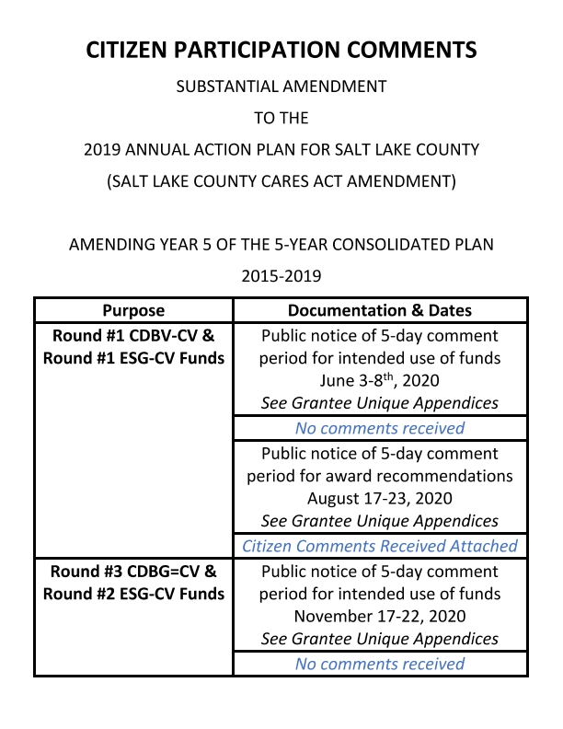
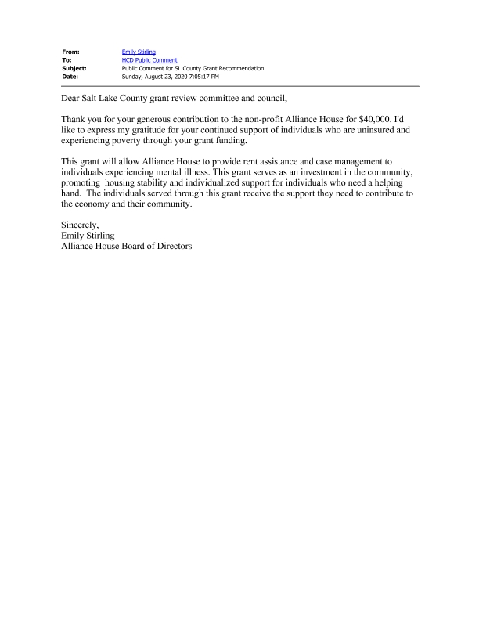
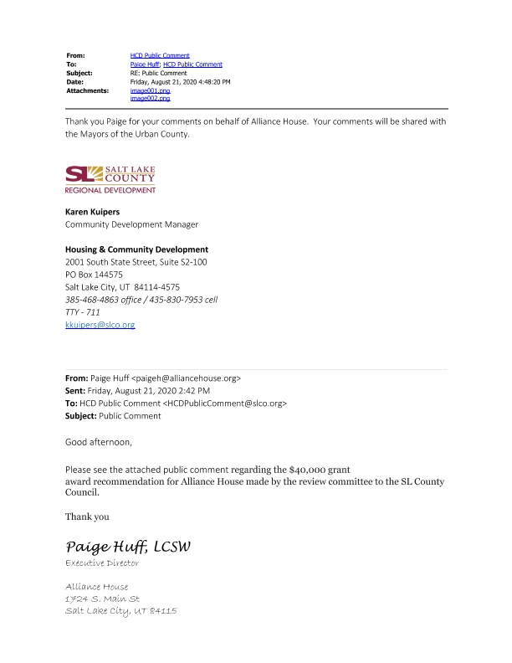
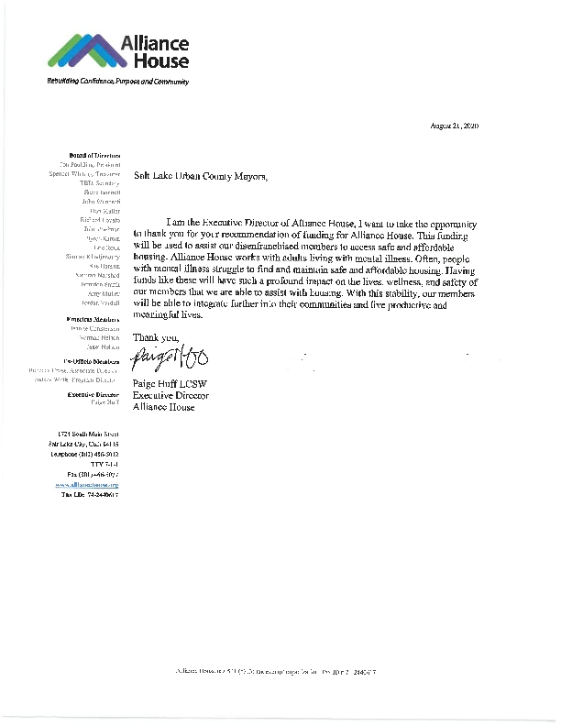
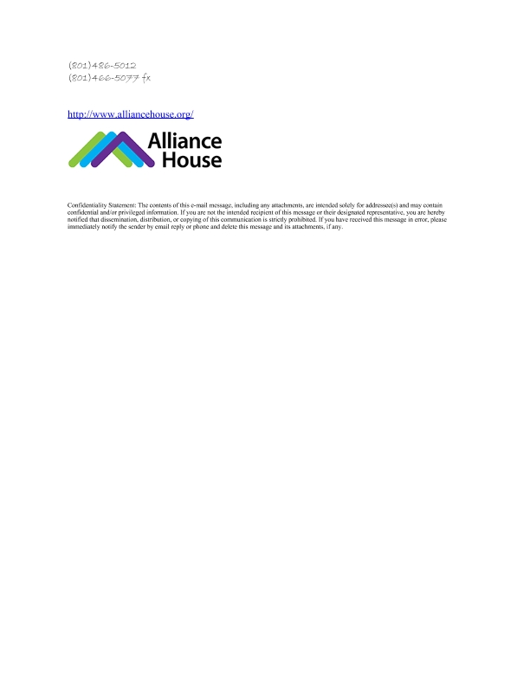
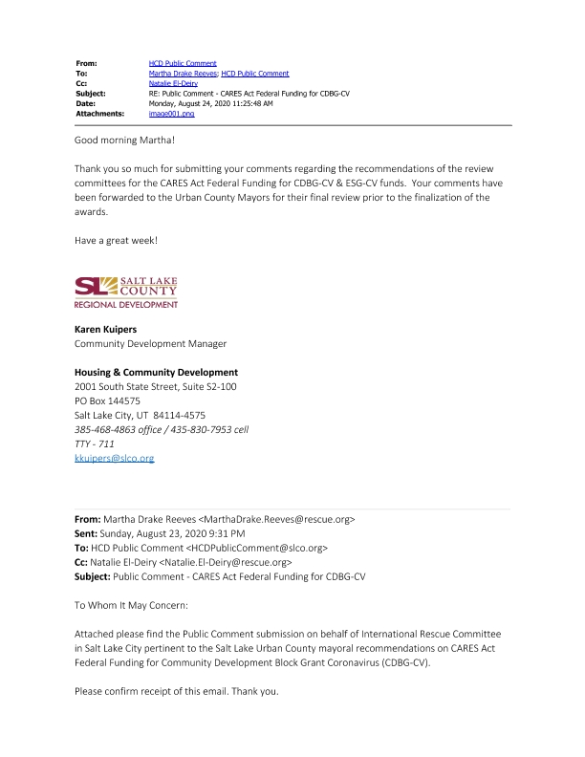
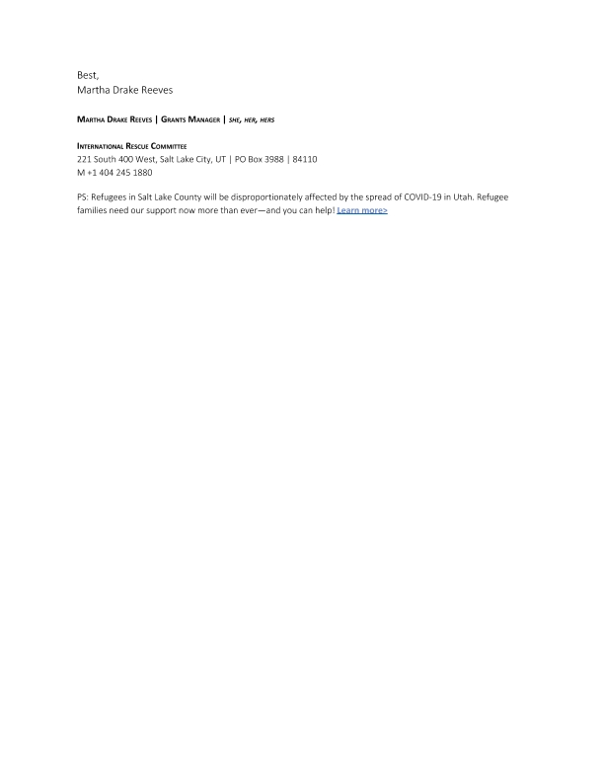
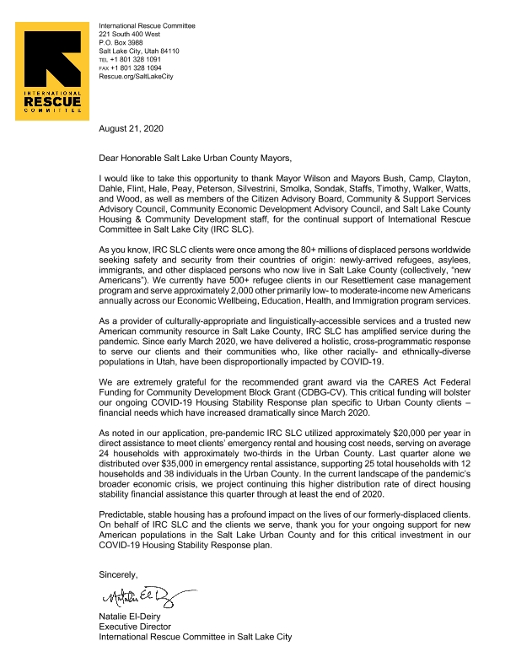
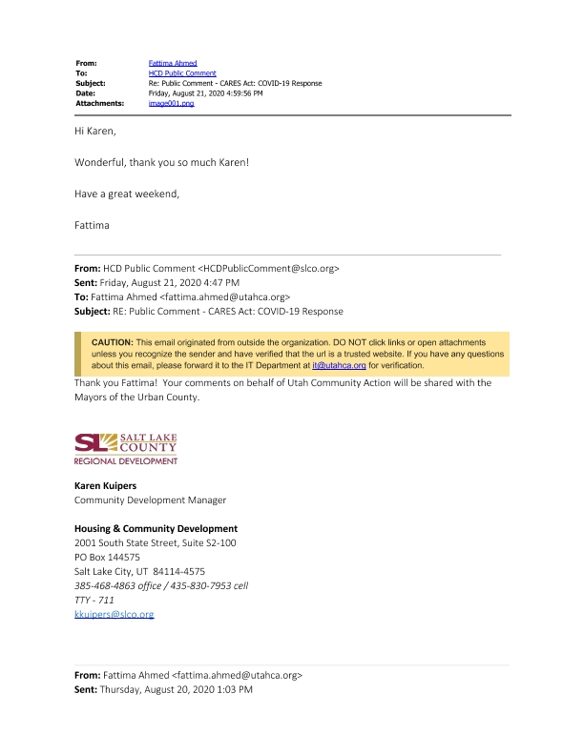
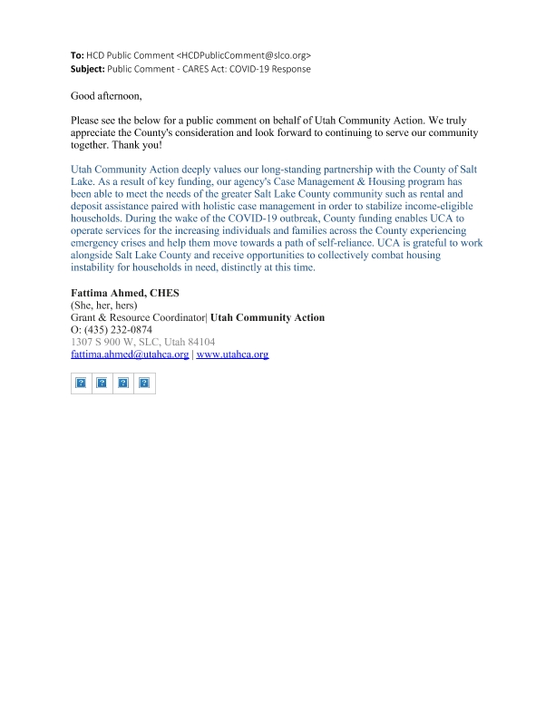
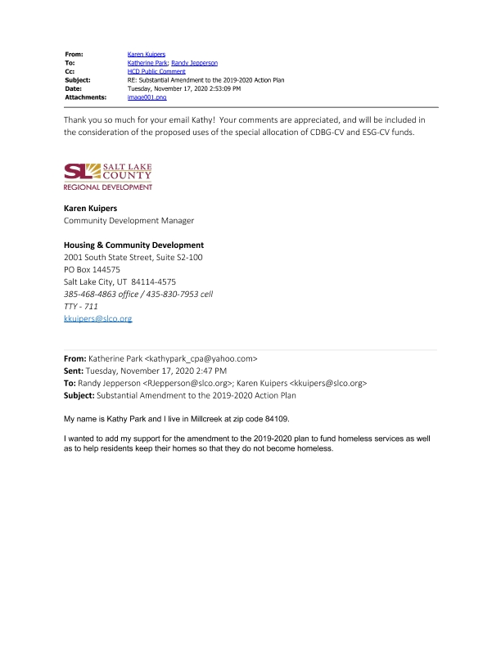

Grantee Unique Appendices
