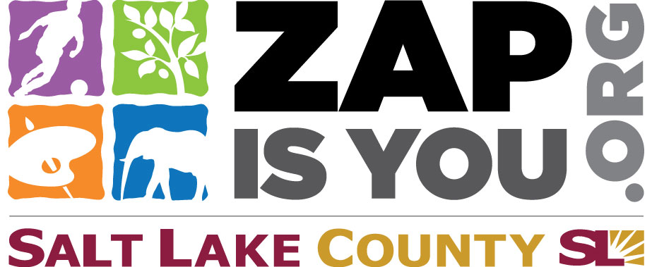

**Utah Arts Festival** is funded in part by the residents of Salt Lake County through the Zoo, Arts & Parks (ZAP) Program

Learn more at   
www. ZAP IS You.org